Contents

Project Proposal 4

Chapter -1Introduction 8

I. Introduction/ Background of the system 9

II. Literature Review 10

❖ It’s got a few stability issues 15

❖ It suffers from relatively poor performance scaling 15

❖ Development is not community driven – and hence has lagged 15

❖ Its functionality tends to be heavily dependant on Addons 15

❖ Developers may find some of its limitations to be frustrating 15

III. Overview 18

Chapter 2 - Analysis 19

I. Analysis 20

II. Use Cases 21

III. Requirement Catalogue 23

IV .Architecture 23

Chapter 3 – Design 25

I. Structural Model 26

II. Behavioral Model 29

Chapter 4 Risk Management and Configuration Management 30

I.Risk Management 31

II. Configuration Management – Directory Structure 31

Chapter 5 Testing 33

Chapter 6 Implementation 45

I. Deployment Diagram 46

II. Data Migration 46

III. Training 47

Chapter 7 Conclusion 49

I. Evaluation against Aims and Objectives 50

Aims and Objectives 50

What have been done 50

Problems Encountered 50

Lessons Learnt 50

II. Evaluation against Similar System Comparison 50

Functional Comparison 50

Usability Comparison 50

III. Evaluation against Justifications Made 50

Language 50

Selected Languages 50

Problems Encountered 50

Database 51

Methodology 51

IV. Evaluation against Project Plan 51

Whether the project is on track with the plan 51

What was complete on time 51

What was not complete on time and why 51

Lessons Learnt 51

V. Future Amendments 51

Design( Class, Use Case) 51

References 51

System Code 52

**Project Proposal**

**“THE FACE SHOP Cosmetics”**

**Online Store Selling System**

**1.1 Current Business Information**

1. **Business History**

Created in Korea in 2003, THE FACE SHOP has revolutionized the world of cosmetics by bringing the nature to the service of beauty. Because Korean beauty rituals are known around the world as the most complete and effective ones, THE FACE SHOP opened its 100th store only a year after its creation. In 2005, the 300th store opened: it was the first THE FACE SHOP franchise of Canada. Owned by LG Household & Healthcare since 2009.THE FACE SHOP now serves customers all over the world. We are passionate about sharing our premium products and spreading the news on the excellence of our products around the world. Originated from Korea, THEFACESHOP is a leading global retail brand in the upper value segment offering more than 1,000 lavish products ranging from skin care (35%), color cosmetic (30%), hair & body care (25%) to accessories (10%).

Our slogan, the "Natural Story", represents over 1,000 high quality products made of 600 natural ingredients such as rice, plants, fruits mineral water and various herbs. Throughout the years, THEFACESHOP is putting tireless efforts in offering our customers attractive prices by taking direct charge of the distribution channel, production as well as research and development without losing sight of our commitment to natural story. THEFACESHOP aims to achieve "Globalization of Products" and "Consistent Communication" all over the world.

With tremendous support by customers, products of THEFACESHOP hit the top sales rank in Korea and in year 2004, it clinched the title of "Best Brand Of The Year". Furthermore, THEFACESHOP achieved the Prime Minister Award in the 10th Korea Distribution Award which was held by the Korea Chamber of Commerce and Industry and Maeil Business Newspaper in 2005. We were also awarded as "Korea Best Hit Brand for the first half of the year 2005" by Seoul Economy Newspaper. In 2009, we clinched another significant title - The 11th Korea Brand Award-Grand Prize (Presidential Award), the only Brand Award granted by the government. We are passionate about sharing our premium products and spreading the news on the excellence of our products around the world. Currently, THEFACESHOP is available in Japan, China, Taiwan, USA, Canada, Dominican Republic, Australia, Vietnam, Philippines, Cambodia, Brunei, Indonesia, Thailand, Hong Kong, Singapore, UAE, Jordan, Mongolia and Malaysia. Overall, we have over 838 outlets in Korea and 318 outlets in 19 countries.

In no event shall the face shop, its affiliated companies or their respective managers, directors, shareholders, agents, representatives or employees be held responsible for indirect, special, consequential or punitive damages, including without limitation the loss of data, profits, revenue, business opportunities or any loss, damage, responsibility, cost or expense arising from or in relation to your purchase of products from the site, the use of the site or the inability to use the site, whatever the origin of the action (contractual responsibility, in tort, negligence, gross negligence or based upon any other legal doctrine, including fundamental breach), even if the face shop has been informed of the possibility of such damages. In the event that the face shop ’s liability towards you may be upheld, it shall be limited to the purchase price of the items that you ordered on the site.

Our target retailer will be lifestyle-based rather than the typical soaps and potions or natural product retailers. These retailers exist in almost every city. Whether it is Wilkes Bash ford in San Francisco, Mario's in Seattle, Harold's in several south central cities, Fred Segal in Los Angeles, Bergdorf Goodman in New York or Colette in Paris. These retailers have developed a loyal and sophisticated customer base. They understand the concept of lifestyle.

Our target customers (vs. end user) for wholesale distribution will be resellers who recognize the needs of this consumer and who she identifies with. We have used the term resellers because they will not be limited to retailers. We will reach the consumer through four distinct reseller channels.

Currently, The Face Shop Cosmetics is available in Japan, China, Taiwan, USA, Canada, Dominican Republic, Australia, Vietnam, Philippines, Cambodia, Brunei, Indonesia, Thailand, Hong Kong, Singapore, UAE, Jordan, Mongolia, Malaysia and Myanmar. Overall, we have over 838 outlets in Korea and 318 outlets in 20 countries. With tremendous support by customers, products of The Face Shop hit the top sales rank in Korea and in year 2004, it clinched the title of “Best Brand of the Year". In 2009, we clinched another significant title – (The 11th Korea Brand Award-Grand Prize (Presidential Award)). The Face Shop aims to achieve "Globalization of Products" and "Consistent Communication" all over the world.

To establish Bluespa as an important brand that represents quality in skin care, fitness apparel and accessories. We will accomplish this using high quality manufacturing and research, a creative marketing program, and a comprehensive distribution network using both brick and mortar retail outlets, internet presence, and a consumer catalogue.

By utilizing this multi-channel approach we will be able to reach the niche market for quality personal care products rapidly and efficiently. It will allow us to develop Bluespa as the brand for quality skin and body care products within our target market.

**Supplier Features**

1. **Supplier Types:**

* Trade Assurance
* Gold Supplier
* Assessed Supplier

View **18,278** Product(s)

**(b) Supplier by Area-**

* + - * Africa
      * Asia
      * Europe
      * Middle East
      * North America
      * Oceania

1. **Suppliers by Country/Region**

|  |  |  |  |  |  |
| --- | --- | --- | --- | --- | --- |
| China | Portugal | Sri Lanka | Shaanxi Chongqing | Pakistan | Australia |
| Guangdong | United Arab Emirates. | Malaysia | Philippines | Romania | Myanmar |
| Guangxi | Thailand | United States | Belgium | Taiwan | Kenya |
| India | Singapore | Russian Federation | Jilin | Shanxi | Yunnan |
| Hong Kong | Sichuan | Beijing | Tianjin | Vietnam | Morocco |
| Japan | Guangxi | Italy | Hunan | Liaoning | Hubei |
| Henan | Zhejiang | Anhui | Jiangxi | Shandong | Fujian |
| Shanghai | South Korea | Jiangsu |  |  |  |

**Future Plan & Business Plan**

With over 500 sample business plans, we have the largest collection of industry-specific business plans. Our examples are based on real-world small business ideas to help guide you as you write your own. At Business plans, our sample business plans include the traditional components of a business plan, such as an executive summary, company summary, products and services, strategy and implementation summary, management summary, financial plan, and appendices. A good business plan follows generally accepted guidelines for both form and content. There are three primary parts to a business plan:

* **The first is the business concept**, where you discuss the industry, your business structure, your particular product or service, and how you plan to make your business a success.
* **The second is the marketplace section**, in which you describe and analyze potential customers: who and where they are, what makes them buy and so on. Here, you also describe the competition and how you'll position yourself to beat it.
* **The financial section** contains your income and cash flow statement, balance sheet and other financial ratios, such as break-even analyses. This part may require help from your accountant and a good spreadsheet software program.

A businessplan consists of seven key components:

* Executive summary
* Business description
* Market strategies
* Competitive analysis
* Design and development plan
* Operations and management plan
* Financial factors

To establish face shop as an important brand that represents quality in skin care, fitness apparel and accessories. We will accomplish this in the following ways:

- High quality manufacturing and research.

- A creative marketing and PR program.

- Creation of a brick and mortar retail presence.

- Development of a wholesale distribution network by the third quarter.

- The successful launch of a Bluespa Web presence by the first quarter.

- The successful launch of a consumer catalogue in the third quarter.

Bottom of Form

1. **Business Processes**

**Purchase** - The Face Shop is a leading global retail brand in the upper value segment offering more than 1,000 lavish products ranging from skin care (35%), color cosmetic (30%), hair & body care (25%) to accessories (10%).

**Order -** Accept order: deliver order and show vouchers and cash. Sales and sales to wholesalers. When the customer comes to pick up the product. If the customer asks any question about the products, they will explain about their products and answer any question.

**Product -** Skin and body care products will be developed and produced at our contract facilities in France and California. Production of apparel products will be managed through our contract manufacturer of sport-related apparel. Production of accessories will be managed through a contract with a manufacturer of quality sports-related accessories including: bags, hats, totes and socks for the wholesale market.

**Sale** - Facial Form, Masks, Skin Care, Makeup, Body Lotion, At the face shop you will find the best product for each step of your beauty ritual: With (over 20 collections of cosmetic products), customer are sure to better natural beauty. Applicable sales taxes are extra and will be shown on screen before confirm customer order.

**Delivery** - The Face Shop strives to have orders delivered as quickly as possible once your order is accepted, using the delivery method you select on the Site. Delivery times and fees will vary based on the shipment destination, delivery method selected and availability of products in inventory. Delivery time calculations are from the shipment’s departure from the face shop premises. Product deliveries are subject to the corporate policies of the delivery companies used by The Face Shop, which presently include and the corporate policies of other delivery companies that The Face Shop may use from time to time.

**Payment** - At present we are not able to accept payment in cash or by coequal. The Site accepts the following credit cards only: Visa Card, Master Card. We reserve the right to stop accepting credit cards from one or more issuers at any time. THE FACE SHOP must receive payment in full for products before they can be shipped to customer.

**Price change -** The Face Shop reserves the right to modify the prices of products on the Site at any time, without prior notice.

**Amount -** The purchase price for each product appears adjacent to it on the Site.

**Promotion -** There is promotions on special days of the years. In promotion, there is discount for products, special promotions and gifts.

1. **Business Issues**

The current system is using manually. Since all the sales are recorded by pen and paper, there is people error in the process. There is also delay in processing. Moreover, the security is also insufficient. To solve all the problems, the current manually system will be changed to computerized system.

**Sales & Order:** The Face Shop is not able to deliver any of the items you order because they are out of stock, we will refund the amount charged to your credit or debit card for these products and send you a refund confirmation by email. If local current exchange rate, we can lose. When explain about the products to not understand customer, explain men are exhausted. ­­­­­­­­­­do not register old customer information so that be risk. When record product information and customer information in the listing book, book can be lost and decay so that can be risk. When staff can be register in the book, can be false and error about the product information and customer information.

**Products**: The Face Shop Cosmetics will not be responsible at any time for any issues that you may incur because products are out of stock. When made design, by the time, machines press the coils, press blocks wrong press. Wrong corrugated. Can be risk in recording by staff.

**Purchase:** It is not easy for purchasing the products by recording the manual system. Staff can be record the wrong data and destroy anyways. If international market situation change, we can lose money. When raw material quantities are bad, we can lose.

**Payment:** The current systems of cashing manually cause delay, wrong and it is not convenience for manually processing customer payment and sold record, vouchers and accounting lists are decay and lost in manual because weather and other fairs. Complex vouchers store is issue if order lists are very much. When come and buy our products by many customer, can be many customers at the casher counter, at this time casher staff can be busy because register product and price of the price for each customer so that can be slow to on time. And many customers wait to pay. So that customer can be being lost by our company.

**Delivery:** The record of the customer order is recorded manually. This can be wrong and the record can lost. The recording process of delivery system should be changed and obstructed traffic so that cannot delivery on time and not experience delivery staff can’t deliver to the customer on time. Can be low moral to buy from our products.

* 1. **Proposed System Scope**
     1. **Process Changes**

Display products, ordering products, selling, payment and delivery systems need to be computerized. Display products on website or online will save customers times to go to physical shop. By changing computerized system for display products can also explain about the book and content of the book. Orderings products with phone calls, customers cannot see the products. If ordering with phone calls is changed to computerized system, the customers will see which product is they wanted by viewing the titles of the book or pictures of the book on display screen. Selling system need to be computerized.

Supplier registration process will be changed to the computerize system from the manual process. Company staff registered supplier name, company name, phone number in manual system. In changing to the computerize system, register supplier ID, supplier name, phone number, company name, company address, email and create supplier registration form and register supplier information in the database. And use update; delete function in the registration form.

Purchase registration process will be changed to the computerize system from the manual registration process. Company staff register in the list book, register raw material name, date, each quantity, total quantity, each amount, total amount in the manual process system. In changing to the computer, create purchase registration form and register raw material ID, raw material name, quantity, price, purchase ID, purchase date, total amount, each amount, quantity, total quantity, government tax, net amount and use calculate function and describe amount. And use update; delete function in the registration form.

Raw material registration process will be changed to the computerize system form the manual registration process. Company staffs register in the list book, register raw material name, quantity, price. In changing to the computerize system, create registration form and register raw material ID, name, quantity, price, image. And use update; delete function in the registration form.

Production registration process will be changed to the computerize system from the manual process system. Company staff record in the list book, record product name, price, color, corrugated product, quantity. In changing to the computerize system, create registration form in which being used this form and register product ID, Name, price, category ID, quantity, corrugated product, product image. And make to use update and delete function. Sale process will be changed to the computerize system form the manual process. Payment process will be changed to the computerize system from the manual record process. By changing this process, this process has not costs of the books and pens will decrease exhaustion of staffs, will decrease the time in this process. This process will be good and become standard quantities. Past and current record will not be lost in this process. Future records will be recorded easily for the process. Record lists and vouchers will not decay.

By changing this process, that can get the many benefit. For example, that can be save the time for the customer and voucher cannot be lost or destroyed.

Payment process will be changed to computerize system from the manual recording process. The staffs don’t need to record the ID of the book and names of the books. And the calculation of prizes cannot be wrong. Because this process will make automatically. Explain of the process will be change to the computerize system from explain to the customers their products. Firstly, create web page in which explain about their products and about their products must write detail about their products with international subject in this web page. By changing this process, their company make staff to give web page address to the customer and know who about their products. By changing that, the staffs will not have exhaustion and decrease time. By changing the process, can be order easily for online customers.

Delivery staffs can record the wrong data of the customer name and address in current business system. But customer will register their name and address in computerized system. So, the problem of recording wrong data for delivery staffs is solved by computerized system.

* + 1. **Estimated costs**

1. **Business Cost**

**Feasibility study:** Feasibility study will takes four days of durations. Feasibility study contains workshop and decision.

* Workshop will take two days.
* Decision will takes two days.

**Foundation:** This stage will take Ten Days durations. An analysis, there are three stages of (Current System Analysis, Proposed System and Requirements.)

* Current system Analysis: This stage will take five days duration.
* Proposed System: This Stage will take five days.
* Requirement: Analyzing the user requirements will take three days.

**Exploration:** The Design stages have four stages and take 2 weeks and four days.

Use Case : This stage will take 10 days duration.

Class : This stage will take eight days durations.

Screen Design : This stage will take five days durations.

Design Document : This stage will take three days durations.

**Engineering:** Implementation stage contains 4 stages and takes 2 weeks durations.

Implement 1 : This task will take Four Days durations.

Implement 2 : This task will take Four Days durations.

Implement 3 : This task will take Four Days durations.

Program : This task will take Two Days durations.

**Deployment:** In Deployment stages, It contains Three Stages. They are

1. Installation
2. Testing
3. Use

-The installation stages will take three days durations.

-Testing stages will take then two days.

1. **S/w cost, h/w cost, License cost, antivirus**

**Software Cost**

|  |  |  |  |
| --- | --- | --- | --- |
| **Software Name** | **Quantity** | **Price** | **Total** |
| Xampp | 1 | Free | Free |
| Sublime Text | 1 | $100 | $100 |
| Microsoft Word | 1 | $120 | $120 |
| MySQL | 1 | $150 | $150 |
| Photoshop design | 1 | &120 | $120 |
| Mozilla Firefox | 1 | $150 | $150 |
|  | Total |  | $540 |

**Sources-** (KMD, 13 July, 2017)

**Hardware Cost**

|  |  |  |  |
| --- | --- | --- | --- |
| **Hardware Name** | **Quantity** | **Price** | **Total** |
| Laptop | 5 | $350 | $1750 |
| Server | 1 | $500 | $500 |
| Printer | 2 | $250 | $500 |
| Scanner | 1 | $200 | $200 |
| Phone | 3 | $180 | $540 |
|  | Total |  | $3490 |

**Sources-** (googlesearch, 10 July,2017)

**Other Cost**

|  |  |  |  |
| --- | --- | --- | --- |
| **Other** | **Quantity** | **Cost** | **Total** |
| Programmer | 3 | $450 | $1350 |
| Developer | 3 | $450 | $1350 |
| Tester | 2 | $300 | $600 |
| Internet Access | 1 | $800 | $800 |
|  | Total |  | $4100 |

**Sources-** (myanmartelecom, 8 July,2017)

**Maintenance Cost**

|  |  |  |  |
| --- | --- | --- | --- |
| Name | Unit | Price | Total Amount |
| Window reinstall | 2 | $58 | $116 |
| Anti- virus | 2 | $35 | $70 |
| Security software | 2 | $75 | $150 |
| Software engineer | 1 | $150 | $150 |
| Hardware engineer | 1 | $100 | $100 |
|  | Total |  | $586 |

**Sources-** (myanmartelecom, 8 July,2017)

**Developing Cost**

|  |  |
| --- | --- |
| Item | Amount |
| System analyst | $100 |
| Developer fees( containing training) | $300 |
| Web hosting | $150(per year) |
| Total | $550 |

**Total Amount of the Project**

|  |  |
| --- | --- |
| Software Cost | $3872 |
| Hardware Cost | $3500 |
| Other Charges | $550 |
| Maintenance Cost | $586 |
| Development Cost | $550 |
| Total Amount | $7922 |

**Payment Schedule**

|  |  |
| --- | --- |
| Start the project | 40% |
| Project Complete | 60% |

* 1. **Aims and Objectives**

1. **Aims**

* To change manual system to computerized system
* To increase more customers
* Advertised Products and Give Information Products
* To solve Issues and more get the customers
* To create E-commerce
* To be popular of the business products
* To resolve the problem of the business issues
* To increase the equities
* To profit for the business

1. **Objectives**

* To solve the issues to be more functions more additional
* To be more functional and more additional
* First we will add and modified some function
* First we convert the manual to computerized system
* To change the computerized system
* Register permission to create web page.
* Create the website
* Advertise the product and about promotion
* Register the product and customer information
* Register the most sale products from the sale center
* Appoint a dynamic website developer
* Appoint a hardware/software engineer
* Register permission to run e-commerce
* We can be save the data and information thus can be protecting loosing book
* When changing the computerized we need to be many steps
* More customer/Market share: create website, discount
  1. **Project Plan (Gantt chart)**

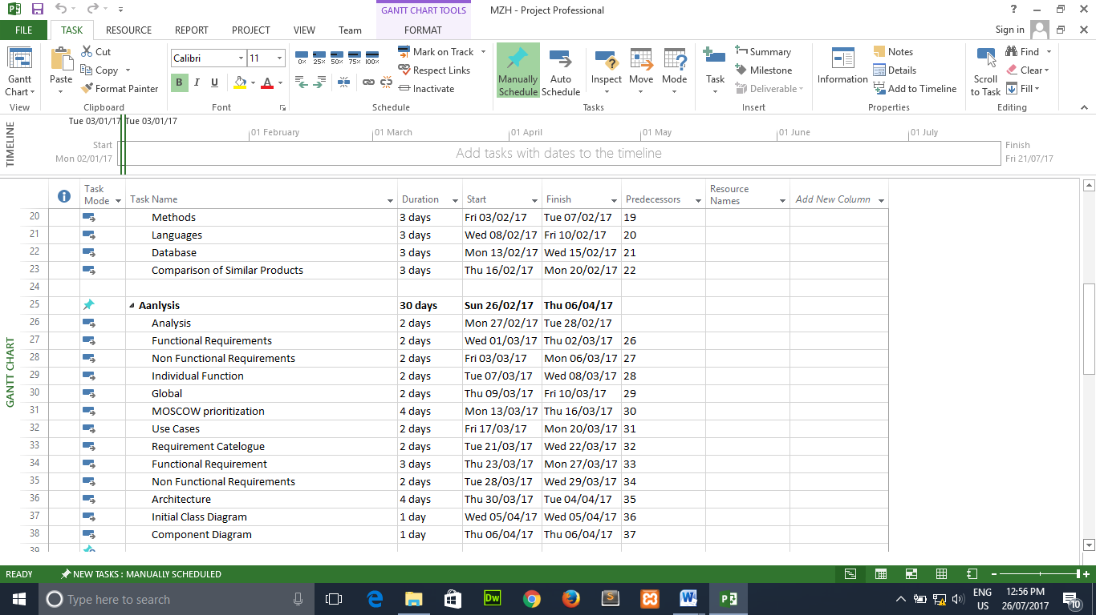

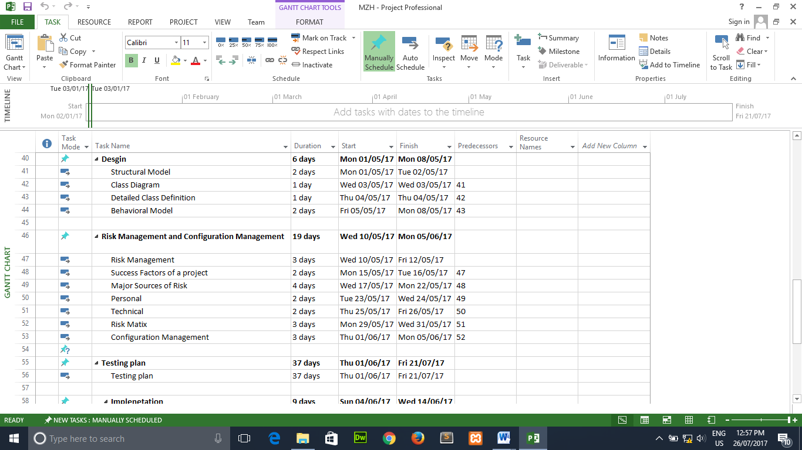

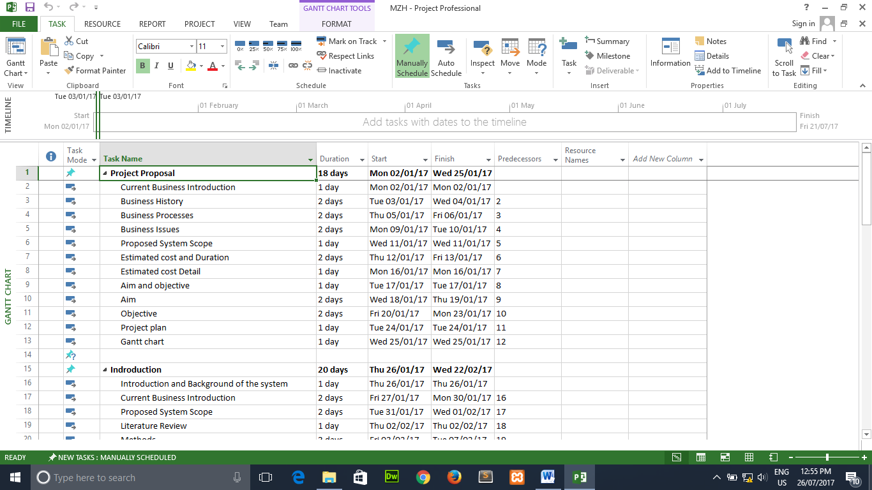

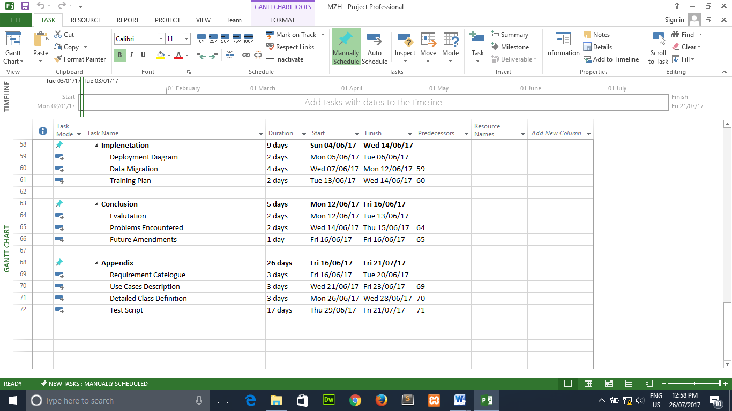

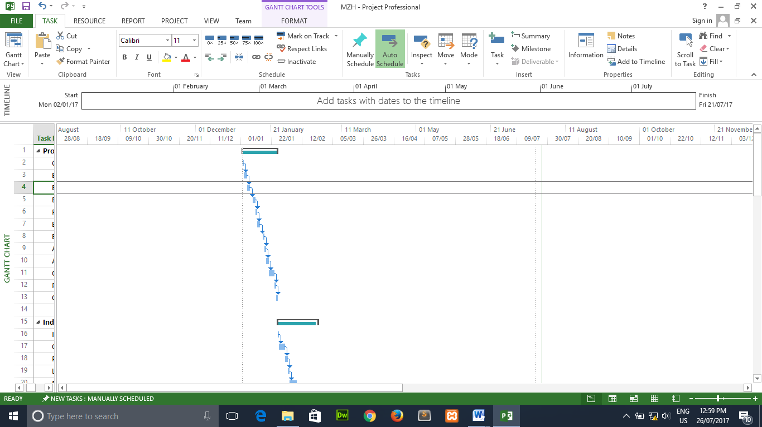

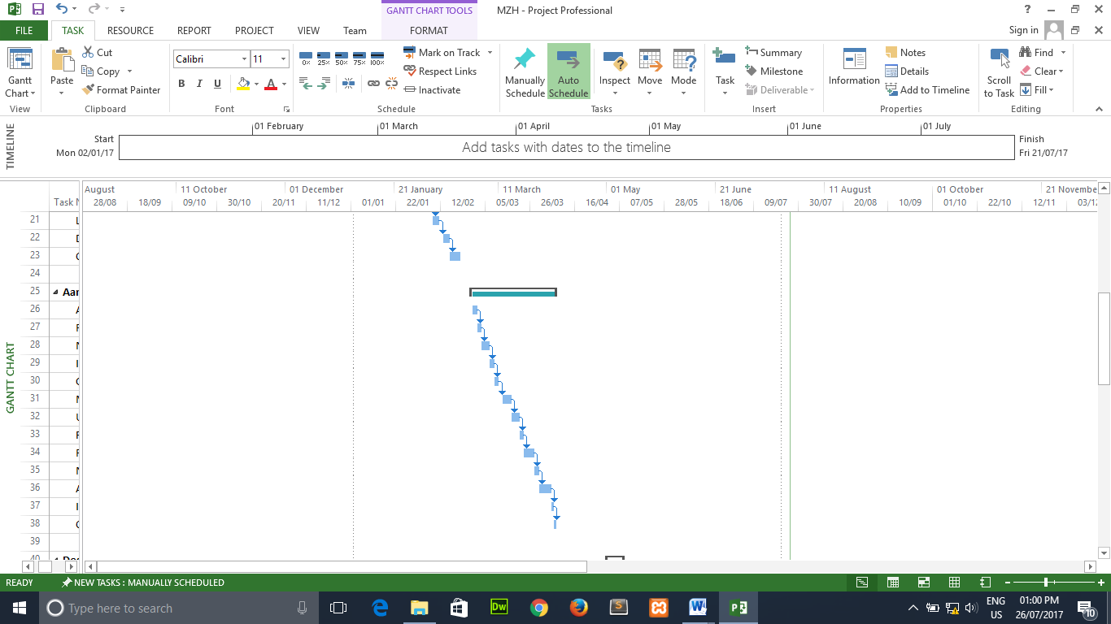

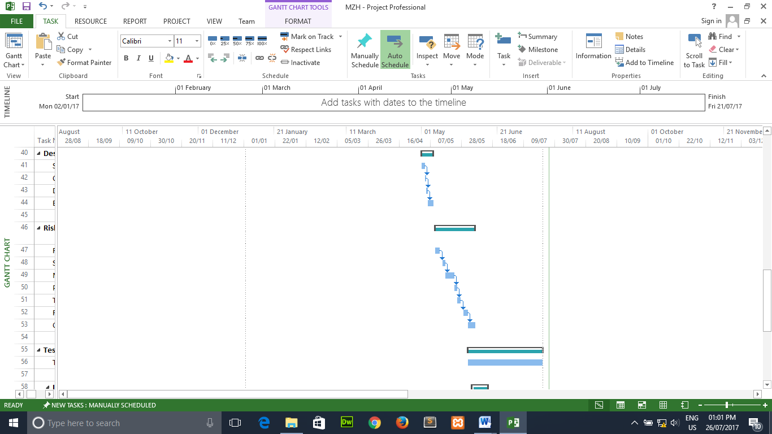

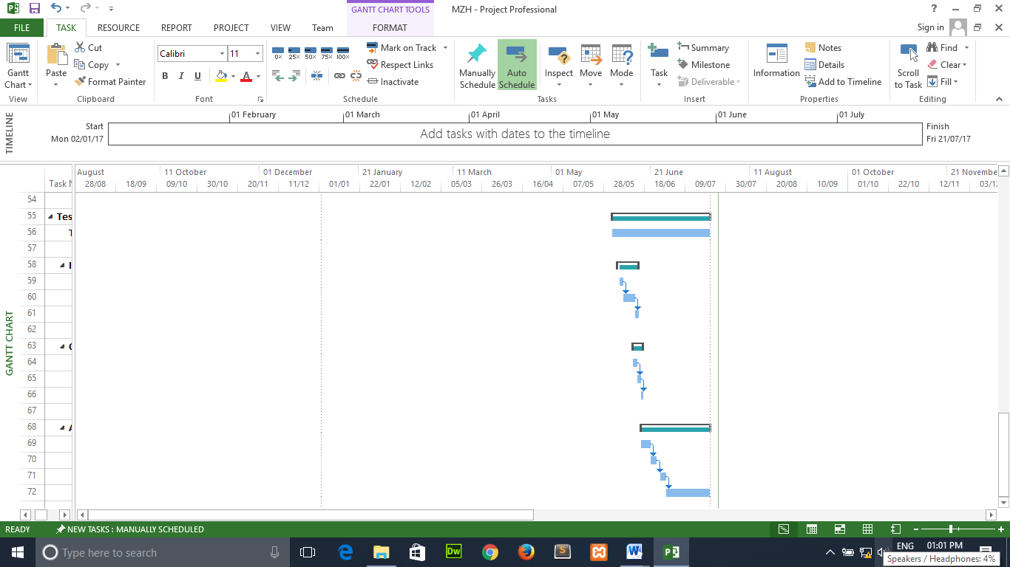

**Chapter 1**

**{Introduction}**

1. **Introduction / Background of the system**
2. **Current business introduction**

During the second half of the 1990s, a strong and steady growth in the sales of organic foods has provided these products with a viable and sometimes value added market niche. Changes in dietary habits among many segments of the population of developed countries - resulting from increased health awareness and the increasing demand for a wider variety of products, including convenience food - have contributed to this growth. Due to major food scares, which hit many countries in Western Europe in the late 1990s and early years of this century, consumers in general have become more critical when purchasing food. The sales of organic horticultural products have been expanding rapidly in many of the major organic markets (e.g. the United States, countries in the European Community and Japan). However, the market share of organic products in total food sales is still small, with shares ranging between one and three percent.

Customs and regulatory authorities have not made a distinction between organic and conventional food products, resulting in a lack of reliable information on organic horticultural market development and internationally traded volumes. Decision-makers in the public and private sector in developing countries therefore lack the necessary information on which decisions should be taken concerning conversion towards organic production. The development of demand for organic products, the type of products and anticipated prices are key issues when deciding on conversion.

Finish products are invoiced to the sale center. There are two main sales centers where from Yangon and Mandalay sale center. In this place, sales these available products are product. These products are delivery by own trust along the sub-way to the sales center. Other wholesalers bought from sale center these products. After sales the products to their region. This process running by using manual system.

1. **Proposed System Scope**

**Online Cosmetics Selling System**

Register the supplier company ID, register company name, register agent name, register company e-mail, register phone number, register company address, register country name. Register supplier name, E-mail, company address, input raw material name, purchase date, purchase quantity, purchase product total amount.

Register the customer name, register the customer e-mail, and register the customer ID, customer phone number, customer address. Register product ID, product name, the most products of the sales center and the most order products. The recording of customer address to deliver will change to computerized system. So, products can be delivered easily and specifically.

Purchase system will be changed to computerized system. Purchasing the selling products can be easy and can reduce the risk of wrong recording than manual recording. The order system will be changed to computerized system. Customer can check the available products and buy from website. Ordered products will be saving with database.

Orders from Facebook can wrong orders and sometimes forget to reply the customers that their orders are received. Memorized only on papers can wrong address, customer names and sometimes we lose these papers? So, we lose customers. To fix that problem is creating the web sites. Memorized in computer systems can’t wrong address and customer names. Also we don’t care to lose the order received. It is also easy to transfer the money on bank account. When we received the order our website will auto reply the customers that his or her order is received. So, we can get orders in 24 hours. Admin need to checks orders on order table. Our admins will check the orders twice a day. In the afternoon and at the midnight

Payment process will be changed to computerize system from the manual recording process. By changing this process, customer can save the time and the payment can be recorded efficiently. Computerized system can’t be wrong to record the amount of price and it will be easy to calculate the annual profit and lost.Nowadays people are not get free times. So, if they want to buy something, they usually buy from online stores. Buying from the online shops can help them to get more free time. They can’t get traffic jump and they can buy anything they want from their home. Most of the shops have their own websites. People can buy cosmetics from online.

Most of the shops are using website to promote their sale. They know that people are more prefer to buy products from online than buying the products from shop. They didn't like to wait the traffic jumps and that can cause tire to them. But people still confuse that buying from online shop can trust. Some p­eople said that products are different that shown in website and product from out site when they delivered. For example, (quality, color, size, lost some parts). So, they buy from the trusted online shops. Some get hacked their accounts and get lied from hackers and fake online website. So, website needs to be trust seller. The Face Shop Cosmetics is already getting trust from customers and also have many customers. And also have good rating from customer in Facebook. Also they want to see simple interface and easy to buy the products.

We make website for parents, teenagers and also collectors. So, our website will use by every ages. So, we have to make website either complex or simple. We have to design to attract every ages. Complex website can make confuse parents when they buy products and simple website can't attract teenagers to buy products. Also they want to see simple interface and easy to buy the products.

In payment system, we make need to connect with banks, money exchanges and also check on delivery. Customer can make payments from banks and money exchanges. We connect with different banks because different customers have different accounts from different banks. If customer didn't have bank accounts they can buy products and make payment when their orders are delivered to them. This can call check on delivery. This system can make teenagers to buy easily our products. So, let us to create your own website with fair price.

1. **Literature Review**
2. **Methods**
3. **Comparison of Agile and Waterfall Model**

**Agile**

**Agile development model** is also a type of [Incremental model](http://istqbexamcertification.com/what-is-incremental-model-advantages-disadvantages-and-when-to-use-it/). Software is developed in incremental, rapid cycles. This results in small incremental releases with each release building on previous functionality. Each release is thoroughly [tested](http://istqbexamcertification.com/why-is-testing-necessary/) to ensure [software quality](http://istqbexamcertification.com/what-is-software-quality/) is maintained. It is used for time critical applications.  Extreme Programming (XP) is currently one of the most well-known agile [development life cycle models](http://istqbexamcertification.com/what-are-the-software-development-models/). Agile is one of the big buzzwords of the IT development industry. Depend on Collaborative, team based, empowered, prioritized. Allow iterative, incremental, and evolutionary. Agile Development” is an umbrella term for several iterative and incremental software development methodologies. The most popular agile methodologies include Extreme Programming (XP), Scrum, Crystal, Dynamic Systems Development Method (DSDM), Lean Development, and Feature-Driven Development (FDD).While each of the agile methodologies is unique in its specific approach, they all share a common vision and core values (see the Agile Manifesto). They all fundamentally incorporate iteration and the continuous feedback that it provides to successively refine and deliver a software system. They all involve continuous planning, continuous testing, continuous integration, and other forms of continuous evolution of both the project and the software. They are all lightweight, especially compared to traditional waterfall-style processes, and inherently adaptable. What is more important about agile methods is that they all focus on empowering people to collaborate and make decisions together quickly and effectively.

**Waterfall**

The Waterfall Model was first Process Model to be introduced. It is also referred to as a **linear-sequential life cycle model.**  It is very simple to understand and use.  In a waterfall model, each phase must be completed fully before the next phase can begin. This type of [software development model](http://istqbexamcertification.com/what-are-the-software-development-models/) is basically used for the project which is small and there are no uncertain requirements. At the end of each phase, a review takes place to determine if the project is on the right path and whether or not to continue or discard the project. In this model [software testing](http://istqbexamcertification.com/what-is-a-software-testing/) starts only after the development is complete. In **waterfall model phases** do not overlap. The project can be divided into distinct stages. Each stage is completed before the next is started. Each stage depends on the previous stage only. Run serial phase the project. Sign off every phase.

**2. Compare (Criteria)**

|  |  |  |
| --- | --- | --- |
| **Criteria** | **Waterfall** | **Agile** |
| Method phase | The software development process is divided into different phases in the Waterfall | Agile methodology segregates the project development lifecycle into sprints |
| Time approach | Waterfall is a structured software development methodology, and often times can be quite rigid and longtime project | the Agile methodology is known for its flexibility and short time project |
| Lifecycle approach | According to the Waterfall model, software development is to be completed as one single project, which is then divided into different phases, with each phase appearing only once during the SDLC. | the Agile methodology can be considered as a collection of many different projects, which are nothing but the iterations of the different phases focusing on improving the overall software quality with feedbacks from users or the QA team |
| Accept and not accept changes approach | If you want to use the Waterfall model for software development, then you have to be clear with all the development requirements beforehand as there is no scope of changing the requirements once the project development starts. | The Agile methodology, on the other hand, is quite flexible, and allows for changes to be made in the project development requirements even after the initial planning has been completed |
| Compare phases | All the project development phases such as designing, development, testing, etc. are completed once in the Waterfall model | while as part of the Agile methodology, they follow an iterative development approach. As a result, planning, development, prototyping and other software development phases can appear more than once during the entire SDLC |
| Testing phase | One of the major differences between Agile and Waterfall development methodology is their individual approach towards quality and testing. In the Waterfall model, the “Testing” phase comes after the “Build” phase | in the Agile methodology, testing is typically performed concurrently with programming or at least in the same iteration as programming |
| Involve stakeholder process | Waterfall methodology is an internal process and does not require the participation of customers | , the Agile software development approach focuses on customer satisfaction and thus, involves the participation of customers throughout the development phase |
| Method of solving process | The Waterfall model can be regarded as a stringently sequential process, | , the Agile methodology is a highly collaborative software development process, thereby leading to better team input and faster problem solving |
| Method of accepting the requirement and method of doing process. | The Waterfall model is best suited for projects which have clearly defined requirements and in which change is not expected at all. | Agile development supports a process in which the requirements are expected to change and evolve. Thus, if you are planning to develop a software that would require frequent overhauls and has to keep up with the technology landscape and customer requirements, Agile is the best approach to follow |
| Mindset approach in using these method | The Waterfall model exhibits a project mindset and lays its focus strictly on the completion of project development. | Agile introduces a product mindset that focuses on ensuring that the developed product satisfies its end customers, and changes itself as the requisites of customer change |

Source- (flatworldsolutions, 2017)

**3. Strength of Agile and Waterfall Methods**

|  |  |
| --- | --- |
| **Agile** | **Waterfall** |
| * Customer satisfaction by rapid, continuous delivery of useful software. * People and interactions are emphasized rather than process and tools. Customers, developers and testers constantly interact with each other. * Working software is delivered frequently (weeks rather than months). * Face-to-face conversation is the best form of communication. * Close daily cooperation between business people and developers. * Continuous attention to technical excellence and good design. * Regular adaptation to changing circumstances. * Even late changes in requirements are welcomed. * As the agile methodology uses less documentation, it saves a lot of time and money. * If any change request or new enhancement comes during the development phase, it can be implemented without considering the budget constraint. * We can determine the issues in advance as there is daily meetings and discussions and therefore able to work on it accordingly. * Quick development and testing helps to recognize the gaps existing in either requirement or technology used and can try to find the workaround. * Customer satisfaction, they can check software release and revert feedback. * In agile process mostly meeting arranged before product release. * More interaction maintained within developing and testing team in this agile process. * Customers can change or add requirements at any stage. * It concentrates on every process with expert team members. | * This model is simple and easy to understand and use. * It is easy to manage due to the rigidity of the model – each phase has specific deliverables and a review process. * In this model phases are processed and completed one at a time. Phases do not overlap. * Waterfall model works well for smaller projects where requirements are very well understood. * The project can be planned using the stages as indicators of progress. * It helps in producing a project plan. * Aids project management. |

**Weakness of Agile and Waterfall Methods**

|  |  |
| --- | --- |
| **Agile** | **Waterfall** |
| * In case of some software deliverables, especially the large ones, it is difficult to assess the effort required at the beginning of the software development life cycle. * There is lack of emphasis on necessary designing and documentation. * The project can easily get taken off track if the customer representative is not clear what final outcome that they want. * Only senior programmers are capable of taking the kind of decisions required during the development process. Hence it has no place for newbie programmers, unless combined with experienced resources * For bigger and complex project, it is difficult to determine the efforts estimation at the beginning of the software development. * For designing and documentation, agile methodology pays less importance. * If the client is unclear about his requirements, there is a chance for messing up the project. * For agile methodology, experience resource will be needed. | * Once an application is in the [testing](http://istqbexamcertification.com/what-is-a-software-testing/) stage, it is very difficult to go back and change something that was not well-thought out in the concept stage. * No working software is produced until late during the life cycle. * High amounts of risk and uncertainty. * Not a good model for complex and object-oriented projects. * Poor model for long and ongoing projects. * Not suitable for the projects where requirements are at a moderate to high risk of changing. * Stages are not always clearly defined-there is often overlap between them. * Does not allow for repetition of stages-often the need to re-visit past stages. A successful project requires the involvement of the client –this is not apparent in the model. * Relationships between non-continuous stages are not shown- there may be connections between non-adjacent stages. * Does not communicate clearly to business managers |

**4. Recommendation of Agile Model**

[Agile methods](https://www.versionone.com/agile-101/agile-methodologies/) grew out of the real-life project experiences of leading software professionals who had experienced the challenges and limitations of traditional waterfall development on project after project. The approach promoted by agile development is in direct response to the issue associated with traditional software development both in terms of overall philosophy as well as specific processes. The benefits of agile software development are that organizations are capable of significantly reducing the overall **risk** associated with software development.

Agile development methodology provides opportunities to assess the direction of a project throughout the development lifecycle. This is achieved through regular cadences of work, known as sprints or iterations, at the end of which teams must present a potentially shippable product increment. By focusing on the repetition of abbreviated work cycles as well as the functional product they yield, agile methodology is described as “iterative” and “incremental.” In waterfall, development teams only have one chance to get each aspect of a project right. In an agile paradigm, every aspect of development — requirements, design, etc. — is continually revisited throughout the lifecycle. When a team stops and re-evaluates the direction of a project every two weeks, there’s always time to steer it in another direction.

The results of this “inspect-and-adapt” approach to development greatly reduce both development costs and time to market. Because teams can develop software at the same time they’re gathering requirements, the phenomenon known as “analysis paralysis” is less likely to impede a team from making progress. And because a team’s work cycle is limited to two weeks, it gives stakeholders recurring opportunities to calibrate releases for success in the real world. Agile development methodology helps companies build the right product. Instead of committing to market a piece of software that hasn’t even been written yet, agile empowers teams to continuously re-plan their release to optimize its value throughout development, allowing them to be as competitive as possible in the marketplace. Development using an agile methodology preserves a product’s critical market relevance and ensures a team’s work doesn’t wind up on a shelf, never released.

Source- (Method, 16 July,2017)

1. **Languages**
   1. **Comparison of PHP & ASP.Net**

**PHP**

PHP is a script language and interpreter that is freely available and used primarily on Linux Web servers. PHP originally derived from Personal Home Page Tools, now stands for PHP: Hypertext Preprocessor, which the PHP FAQ describes as a "recursive acronym." PHP is an open source technology which can be used for free. PHP is a programming language that is use for creating web application. PHP will work well in any kind of platform and server. PHP was launched by Rasmus Lerdorf in the year of 1995.PHP work well with MySQL database. MySQL database is also available for free. PHP can run in Linux Operation System which is available for free. PHP execution is faster because PHP uses in built memory space. Coding using PHP is very easy when compared to all other programming languages.

**ASP.Net Languages**

ASP.net is a Microsoft technology that is expensive in price.ASP.net is a platform in which programming languages such as VB.NET or C# can be used to create ASP.net applications.ASP.net can be used only with internet information server(IIS).ASP.net was launched by Microsoft in the year2002.ASP.net mostly works with MS-SQL database, which also belongs to Microsoft and MS-SQL is not available for free.ASP.net cod execution is comparatively slower because it will until the server space during execution.It was developed by Microsoft to allow programmers to build dynamic web sites, web applications and web services. It was first released in January 2002 with version 1.0 of the .NET Framework, and is the successor to Microsoft's Active Server Pages (ASP) technology.

* 1. **Compare PHP and ASP.net (Criteria)**

|  |  |  |
| --- | --- | --- |
| **Criteria** | **PHP** | **ASP.net** |
| Price for using these software | PHP is an open source technology which can be used for free. | ASP.net is a Microsoft technology that is expensive in price. |
| Use for application in using the language | PHP is a programming language that is use for creating web application. | ASP.net is a platform in which programming languages such as VB.NET or C# can be used to create ASP.net applications. |
| Use for sever | PHP will work well in any kind of platform and server | ASP.net can be used only with internet information server(IIS). |
| Launched time the language | PHP was launched by Rasmus Lerdorf in the year of 1995 | ASP.net was launched by Microsoft in the year2002. |
| Use for working will with other software | PHP work well with MySQL database. MySQL database is also available for free | ASP.net mostly works with MS-SQL database, which also belongs to Microsoft and MS-SQL is not available for free. |
| Execution faster and slower | PHP execution is faster because PHP uses in built memory space. | ASP.net cod execution is comparatively slower because it will until the server space during execution. |
| Compare coding for the language | Coding using PHP is very easy when compared to all other programming languages. | Coding using ASP.net is complicated and it requires lot of learning and effort |
| Useful for these language with other platforms | PHP is compatible to work on different platforms such as Windows, UNIX and Linux. | ASP.net works with windows platform. If ASP.Net has to be used in Linux, then ASP. Apache has to be installed in the server. |
| Price for using with tools | Many useful tools that can be used with PHP are available for free. | Tools that can be used with ASP.Net are not available for free |
| Similar of these language with other languages. | PHP syntax is similar to the syntax of C and C++ programming languages. | The syntax and concepts of ASP.Net are similar to the syntax of Visual Basic. |

Source- (rapidprogramming.com, 2017)

* 1. **Strength of PHP & ASP.Net Languages**

|  |  |
| --- | --- |
| **PHP Languages** | **ASP.Net Languages** |
| * PHP, on the other hand, is relatively inexpensive and secure and has several of its own advantages. * PHP works by teaming up with HTML to display dynamic elements on a web page. * The most notable thing about PHP is that it is commonly included as the “P” in LAMP architecture. * LAMP is a software bundle that includes Linux, Apache, MySQL, and PHP. * These are all inexpensive, scalable, and secure web applications. The bundle is a popular way to distribute these applications. * Open source: it is developed and maintained by a large group of PHP developers, this will helps in creating a support community, abundant extension library. * Speed: It is relative fast since it uses much system resource. * Easy to use: It uses C like syntax, so for those who are familiar with C, it’s very easy for them to pick up and it is very easy to create website scripts. * Powerful library support: You can easily find functional modules you need such as PDF, Graph etc. * Stable: Since it is maintained by many developers, so when bugs are found, it can be quickly fixed. * Can be run on many platforms, including Windows, Linux and Mac, it’s easy for users to find hosting service providers. | * ASP.NET significantly reduces the amount of code required for building large and complex applications which can increase overall development speed and reduce development costs. * ASP.NET Framework supports varied languages; it allows you to select the language that better applies to your application. * ASP.NET provides ability of cross platform migration. * ASP.NET provides simplicity making it easy to perform common tasks including configuration and deployment. * ASP.NET ensured high reliability and security due to built-in Windows authentication and per-application configuration. * ASP.NET is regularly updated by Microsoft to meet the most up-to-date technology requirements. * **C#** is one of the most beautifully designed languages. It’s much more modern than Java or PHP and does not have design flaws like JavaScript and is strongly typed unlike Python and multi-purpose unlike Ruby. * If you want, you can use F# for some part or even entire application where functional programming is more suitable. * C# and F# are 100% compatible, which means you can use C# libraries in F# and vice versa. |

*(Ref;* (PHP Ns ASP.Net, n.d.)

**Weakness Of PHP & ASP.Net Languages**

|  |  |
| --- | --- |
| **PHP** | **ASP.Net** |
| * PHP has a few drawbacks. PHP can only parse code within its delimiters, and anything outside the delimiters is sent directly to the output. * PHP also lacks name spacing, which can result in class naming collisions. * Additionally, variables in PHP are not really considered to have a type, and type checking is very loose, which can potentially lead to problems. * Finally, despite the high quality of much of the free or inexpensive software out there, some big corporations feel the low price of PHP suggests that it is not worth buying. * Security: Since it is open sourced, so all people can see the source code, if there are bugs in the source code, it can be used by people to explore the weakness of PHP. * Weak type: Implicit conversion may surprise unwary programmers and lead to unexpected bugs. For example, the string “1000” and “1e3” compare equal because they are implicitly cast to floating point numbers. * Not suitable for large applications: Hard to maintain since it is not very modular. | * The main disadvantages of ASP.NET and Visual Studio are that they are expensive and their upkeep is resource intensive. * Most ASP.NET applications run on IIS. * Additionally, ASP.NET uses far more web server resources than PHP or other languages, so it requires either better servers or a greater number of them. * Finally, Windows and IIS have a documented history of bugs and vulnerabilities in the programs have been prone to exploitation in the past. * ASP.net is a Microsoft technology that is expensive in price. * ASP.net can be used only with internet information server(IIS). * Tools that can be used with ASP.Net are not available for free |

**Source-** (language, 18 July,2017)

* 1. **Recommendation of PHP Languages**

In reviewing PHP vs. ASP.NET, both languages have their strengths and weaknesses. PHP is inexpensive, secure, fast, and reliable. ASP.NET may be easier to use and maintain because of its class library system. Since both languages can essentially accomplish the same things, the choice between these two giants of programming language really comes down to what a company is looking for regarding price, speed, security, and reliability.

PHP is an open source technology which can be used for free. PHP is a programming language that is use for creating web application. PHP will work well in any kind of platform and server. PHP work well with MySQL database. MySQL database is also available for free. PHP execution is faster because PHP uses in built memory space. Coding using PHP is very easy when compared to all other programming languages.

PHP is quite simple language comparing to ASP.NET (.NET actually) which is a complete framework that offers a wide range of possibilities (yeah I made a comparison). Maybe PHP has a simple learning curve comparing to ASP.NET, but on the other hand, it doesn’t mean that web designers should limit their selves just to PHP. Why not be familiar with other technologies as well?

The other thing that might be important is that PHP was always free, unlike ASP.NET However, today you can build rich ASP.NET applications for free. You have Visual Web Developer, Visual C# and SQL Server Express which are all free. And not only that, you can download Web Platform Installer that will install all necessary software for ASP.NET development. So, no more excuses.

1. **Database**
   * + 1. **Comparison of MySQL & Access**

**MySQL**

**MySQL** is an open source relational database management system (RDBMS) based on Structured Query Language (SQL). ... LAMP is a Web development platform that uses Linux as the operating system, Apache as the Web server, and MySQL as the relational database management system and PHP as the object-oriented scripting language. MySQL is an open source database management system. It is highly popular because of its high reliability, ease of use and high performance. MySQL is used for many latest applications that are built on Apache, Linux, Perl/PHP etc. Many popular organizations such as Google, Alcatel Lucent, Facebook, Zippos’ and Adobe rely on this database management system. MySQL can run on more than twenty platforms that include MAC OS, Windows, Linux, and provides much flexibility. A wide variety of database tools, services, training and support is provided by MySQL database system. MySQL is open source program. It is in easy reach of small businesses.

**Access**

A means of approaching, entering, exiting, or making use of; passage. The space required to view a tooth and manipulate dental instruments to remove decay and prepare the tooth for restoration. The opening in the crown of a tooth necessary to allow adequate admittance to the pulp space to clean, shape, and seal the root canal. There are very strong views about MS Access. Its detractors call it a toy database; good for playing with but not for serious corporate use. Yet there are people with equally strong opinions who swear by the product. They cite the ease of use in a whole lot of situations.

1. **Compare MySQL and Oracle Database(Criteria)**

|  |  |  |
| --- | --- | --- |
| **Criteria** | **MySQL Database** | **Access Database** |
| Cost , installation and features | MySQL is an open source and MySQL is available for free download and installation. | Only Access Express Edition is free of cost. But Access Express Edition has very limited features when compared to MySQL. For extensive features, either Access Standard Edition has to be purchased. |
| Compare authentication in using these software | User authentication is performed in MySQL by using only location, username and pad word. | Access provides enhanced database security. User authentication is performed in Access by specifying global roles in addition to location, username and password. In Access, User authentication is performed by different authentication method including database authentication, external authentication and proxy authentication. |
| Compare flexibility in using these software | Flexibility of creating stored procedures and functions using PL/SQL is very less in MySQL. | Access provides more flexible features for creating stored procedures a commands and functions using PL/SQL. |
|  | MySQL does not have the audit vault feature in the server. | Access provides audit vault facility. |
| Compare offer tool for enterprise level in using these software | MySQL does not offer tools at enterprise level. | Access offers tools at enterprise level. |
| Compare facility using these software | MySQL has only table looking facility. | Access provides the row locking facility as well. |
|  | MySQL does not have extensive storage features like table space, synonym, packages and many others. | Access has a very extensive storage features. Oracle supports table space, synonym, packages and all other features. |
| Compare supporting for XML | MySQL database does not support XML. | Access supports and uses XML. |
| Compare support for datatype in using these software | MySQL supports only two character types namely CHAR and VARCHAR. | Oracle supports four different character data types namely; CHAR, VARCHAR2, NCHAR, and NVARCHAR2. |
|  | MySQL, temporary tables are visible only within the current active session. When the session expires, the temporary tables are removed automatically. | In Oracle, temporary tables are persistent across sessions. The temporary table has to be explicitly removed by the User. |
| Compare About the backup mechanisms in using these software | MySQL has only two backup mechanisms namely mysqlhotcopy and MySQL dump. | Oracle offers many backup mechanisms including hot backup, backup, import, export and, any others. |

Source- (quora, 2017)

1. **Strength Of MySQL & Access**

|  |  |
| --- | --- |
| **MySQL** | **Access** |
| It’s Easy To Use: MySQL is very easy to install, and thanks to a bevy of third-party tools that can be added to the database, setting up an implementation is a relatively simple task.Support Is Readily Available Whenever Necessary: Although Oracle’s history of supporting its customers can be spotty at best, the nature of MySQL – which got its start as an open-source platform.It’s Open-Source (Sort Of): Oracle’s purchase of Sun Microsystems (and by association, MySQL) was [met with some contention from the development community](http://techcrunch.com/2012/08/18/oracle-makes-more-moves-to-kill-open-source-mysql/). The general fear was that Oracle would transform the tool into a closed, proprietary ecosystem.It’s Incredibly Inexpensive: Depending on what you plan to use it for, a MySQL implementation could [range in price from free to $10,000](http://www.mysql.com/products/) or more. it’s significantly less expensive than most other database options on the market .It’s An Industry Standard: Although MySQL’s popularity has waned somewhat in recent years, it remains one of the most-used database systems in the world.  * SQL can retrieve large amount of data record quickly because it has high speed. * No coding required. * It is inexpensive.  It has great performance. | * The first advantage that comes to mind is how familiar the interface is to most users. * The Office 2007 interface style is familiar, so users who have other Office products will not be lost when dealing with Access. * There are two ways to view the database, no matter whether you are creating a new one or opening something existing. * The data view and the design view make it easy to set up Access and start using it. * All kinds of rules to make sure you enter the right kind of data can be implemented. * Access has become an industry standard in desktop use and the database engine is quite powerful. * Integration with voice recognition features makes data entry and menu navigation quite easy. * The ability to customize them not only lets you get productive quickly, but you can also adjust things to fit your specific needs. * Connectivity options are a strong asset; Access databases can connect to Excel tables, ODBC connectors, SQL Servers, and SharePoint Services sites for live data. * It is easy to install and use. * It is useful for relational database solutions. * It has convenient storage capacity. * It supports multi-user. * It easy to import data. |

*(Ref;* (rapidprogramming, n.d.)*,* (What is MySQL, n.d.)*,* (What is access?, n.d.)*)*

**Weakness of MySQL & Access**

|  |  |
| --- | --- |
| **MySQL** | **Access** |
| It’s Got A Few Stability Issues  * [According to Digital Ocean](https://www.digitalocean.com/community/articles/sqlite-vs-mysql-vs-postgresql-a-comparison-of-relational-database-management-systems), MySQL tends to be somewhat less reliable than its peers. These stability issues are related to the manner in which it handles certain functions (such as references, transactions, and auditing).  It Suffers From Relatively Poor Performance Scaling  * Although MySQL is equipped to handle a virtually limitless volume of data, it has a troubling tendency to come grinding to a halt if it’s forced to deal with too many operations at a given time.  Development Is Not Community Driven – and Hence Has Lagged  * Since Oracle has taken the helm of MySQL’s development, progress appears to have ground to a halt, with only one major release in the past several years.  Its Functionality Tends To Be Heavily Dependent On Add-ons  * Although MySQL is relatively easy to set up, it tends to have less out-of-the-box functionality than many other database systems on the market. * It is not support a very large database size. * Transactions are not handled very efficiently. | * Access has been designed for desktop use, more like a personal database. * It can support multiple users over a workgroup alright; the total number of users (usually around 50 or so simultaneous) is small however. * That means Access is more useful for individual departments or the SMB (small and medium business sectors). * As you scale up the size, performance becomes sluggish (almost to the point of unresponsiveness). * Use of multimedia data, even your digital camera photos can eat up space very quickly. * Though the [attachment](http://www.brighthub.com/computing/windows-platform/articles/40641.aspx) field in Access 2007 takes care of that, the overall 2 GB space could limit you very quickly. * Many indicate that the SQL Server is a more real database, since it competes with enterprise-level databases like Oracle. * Another difficulty pointed out by many is how publishing anything other than static files is a problem with Access. * Access is work only on Windows. * It is needs to buy. * Only one database can be open at a time. * All the information from database can save in one file. |

1. Recommendation of MySQL

MySQL is very popular for Web-hosting applications because of its plethora of Web-optimized features like HTML data types, and because it's available for free. It is part of the Linux, Apache, MySQL, PHP (LAMP) architecture, a combination of platforms that is frequently used to deliver and support advanced Web applications. MySQL runs the back-end databases of some famous websites, including Wikipedia, Google and Facebook- a testament to its stability and robustness despite its decentralized, free-for-all philosophy. Their project requires simple queries and has small concurrency rate.

MySQL database management system is a popular than other database system. This relational database management system is faster than the other one. I want to use MySQL with PHP. Staff can only be use MySQL database. Their project requires simple queries and has small concurrency rate. MySQL database management system is a popular than other database system. This relational database management system is faster than the other one. I want to use MySQL with PHP. Staff can only be use MySQL database.MySQL provides implementation of a SQL database very well suited for small to medium web pages.

The database is free and open source with a commercial license available (MySQL is now owned by Oracle after they bought. Common applications for MySQL include PHP and java based web applications that require a DB storage backend. MySQL has one major advantage, since it is free, it is usually available on shared hosting packages and can be easily set up in a Linux, Unix or Windows environment. If a web application requires more than database, requires load balancing , it is easy to set up maybe instances of the database requiring only the hardware costs, as opposed to commercial databases that would require a single license for each instance.

Source- (MySQL, 20 July,2017)

1. **Comparison of Similar Products**
2. Beauty Diary (<http://www.beautydiarycosmetics.com>)

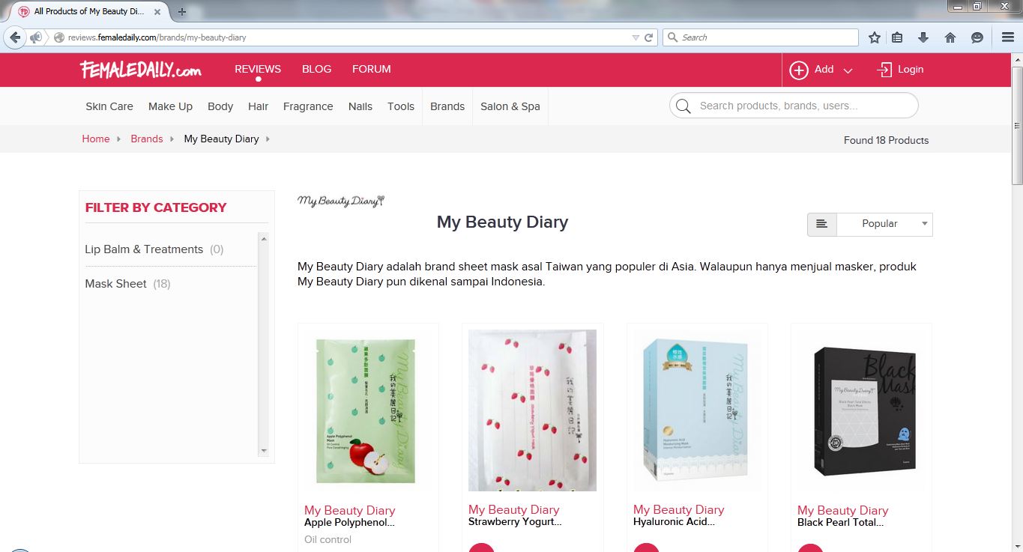

Source-(Cosmetic, 2017)

Nature Republic (<http://www.naturerepublicofficial.com>)

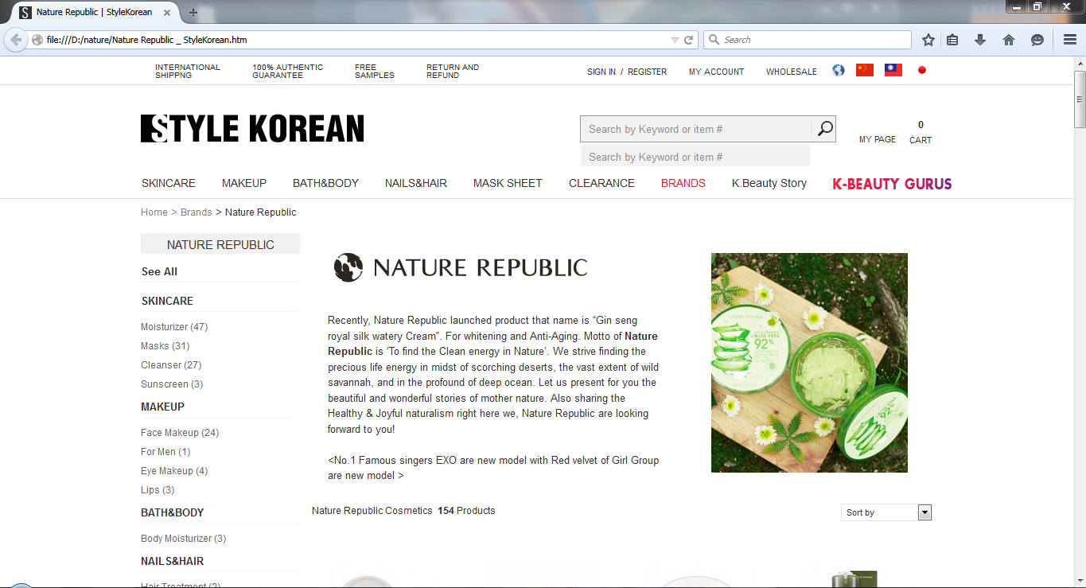

Source- (Product, 2017)

1. **Comparison in a table for Similar Products**

|  |  |  |
| --- | --- | --- |
| **Content** | **Beauty Diary** | **Nature Republic** |
| Menu | It is perfect to look but not attractively real. | It is simple but attractively real. |
| Color | This color is a complex website. | The color of Nature Republic is simple. |
| Navigation | It looking good for design but not perfect ,it has been use classical design | It is classical design but perfect. Its design is difficult to understand to user. |
| Home page | It is simple. | If perfect functions. |
| Registration` | Customer register is simple. | It is customer service. |
| Delivery services | This Page is simple service. | Perfect Deli-Service |
| Search | It is so easy. | Search box is effect information |

Source- (Comparison, 2017)

1. **Strengths and Weaknesses of Similar Products**

|  |  |  |
| --- | --- | --- |
| Content | Beauty Diary | Nature Republic |
| Strength | It is simple so easy to use this and easy to understand | It is perfect for design and attractively, also functions. |
| Weakness | It is need some function that is difficult to user. | Its design is difficult to understand to user. |

1. **Recommendation of Similar Products**

The Best Cosmetics included benefit is

* Special discount for members during new product launch
* FREE beauty workshop for members.‎
* SMS & Email Blast from time to time
* Members' Pre-Sale - additional 10% discount
* Sales period - members are entitled for additional 5 % discount
* Birthday Treats - 30% discount voucher & FREE Mystery Birthday Gift which have just started these months.

Source- (Advantages, 2017)

**Evaluation**

If compare water fall model and Agile, I choice Agile because I want to use DSDM Atern at sale of point system. If compare PHP and ASP.net, choice PHP Language because want to use with MySQL database and PHP is free and easy to write over other language for dynamic. If compare MySQL and Oracle database, choice MySQL database because want to use with PHP Language, it is free, and it is easier for users to remember the comments and work with it. The relational database management system is faster than other one. If compare two websites, choice to use the advantages of two websites.

## Overview of Remaining Chapter

**Chapter 2**: This chapter is about analysis. We are analysis the project about functional requirement and non-functional requirements. Also draw the diagrams such as use case, initial class and component diagram and Moscow prioritization.

**Chapter 3**: This chapter is about design. We make Sequence diagram and Detail class diagram.

**Chapter 4**: This chapter is about risk management and configuration management. We wrote about risk management, critical success factors of a project, Major Sources of risk, personal, technical, risk matrix and configuration management.

**Chapter 5**: This chapter is about testing plan. We test about the test of the project.

**Chapter 6**: This chapter is about Implementation. We draw deployment diagram and write about data migration, Training plan.

**Chapter 7**: This chapter is about conclusion. We write about evaluation about database, language, design and method. We also write problem encounters, solution and references. We also write appendix. The appendix contain requirement catalogue, use case description, detailed class definitions, test scripts, user guide and system code.

**Chapter 2**

**{Analysis}**

* + - 1. **Analysis**

1. **Functional Requirements**

Purchase Product

Staff will purchase the products by transfer money from bank. Purchasing the products will last 1 or 2 weeks. Customers are purchase the products from website. To ensure their purchase, they need to transfer 20% of product price from bank account.

Record Product

Staff records the products which are arrived from the supplier. These recorded products will be shown in product page. And also staff will recorded the products which are bought by the customers.

Customer Register

Customers need to register before they order products. They can check their orders and can cancel their orders. They can have their private accounts and

No one can see what they order and personal detail.

Make Order

Staff checks the products which are ordered. They check the delivery date, time, location and quantity.

Promotion Register

Staff deliver products which are ordered by customers. They offer door to door service.

Record Delivery Information

Customer can make payment with bank account. They only need to transfer money from the bank. And also they can make payment when the order is arrived.

1. **Non Functional Requirements**

**b.1. Individual function**

Product Registration

* + Volume: No. of orders (20 – 30 ) per day accepts in the business
  + Response Time: 5 minute
  + Frequency : 20 – 30 per day

Purchase Product

* + Volume: No. of orders One week accepts in the business
  + Response Time: Half Hour
  + Frequency : One week

Customer Register

* + Customer Register Volume: No. of orders One week (or) Three weeks accepts in the business
  + Response Time: 1 day
  + Frequency : One week (or) Three weeks

Make Order

* + Volume: No. of orders Day By Day accepts in the business
  + Response Time: 5 Min
  + Frequency : Day By Day

Promotion Register

* + Volume: No. of orders one week (or) two week accepts in the business
  + Response Time: Half Hour
  + Frequency : 1 week (or) 2 week

Record Delivery Information

* + Volume: No. of orders day by day accepts in the business
  + Response Time: 5 min
  + Frequency : day by day

**b.2. Global**

* **Performance**

When the customer watches into the website the customers can see clearly the type of THE FACE SHOP Cosmetics. And the customer can also find the photos of cosmetics and can easily order it. The customer can also see the new products.

* **Interface**

If also need business of web page, it is useful in attraction of customer. Its interface will be good. Customer can be pleasure. It is not good customer may be annoyed and interface need to be beautiful and also need in simple. If interface is complex, customer can’t use easily.

* **Security**

The Customer password must have at least 8 characters and long. If they want to change new passwords users need to enter their current password. Set the security Instead of login and confirm transfer without security code.

* **Reliability**

It is also required because no reliability in customers this business can’t stand itself. So it should try to obey in business rule and have a good reliability, as in accuracy in time, accuracy in service.

* **Maintainability**

Can transfer this project to maintain between any programmer because there are related and meaningful variable name or function name in coding when initial stage of Project.

1. **MOSCOW prioritization**

|  |  |  |  |  |  |
| --- | --- | --- | --- | --- | --- |
| **Function Name** | | **Must Have** | **Should Have** | **Could Have** | **Won’t Have/Would** |
| Product Registration | |  |  |  |  |
| Purchase Product | |  |  |  |  |
| Customer Register | |  |  |  |  |
| Make Order | |  |  |  |  |
| Promotion Register | |  |  |  |  |
|  | Record Delivery Information |  |  |  |  |

**Reason for Function**

Product Registration - Staff need to record the products that are going to sell.

Purchase Product - Online shop need purchase the products to sell the customer.

Customer Register - Customer need to register to buy the products from website.

Make Order - Customer need to check the order twice a day.

Promotion Register - Customer makes payment when order by product.

Record Delivery Information - Products are delivers to customer’s address.

* + - 1. **Use Case Diagram**



**Description of Use Case Diagram**

Process Name: **Product Registration**

Actor: Staff

Pre-process: Register of products name, price and products

Description: Display product on website or display screen. Products will be registered according to the alphabet of the title of products with the aim of easier searching for customers. In this search box will be contains to search products, also containing explanation of products of information of the products in detail.

Process Name: **Purchase Product**

Actor: Staff

Pre-process: Record the products, record suppliers and date /time

Description: Make order products from suppliers .Name of the suppliers, types of suppliers and region of suppliers are contain in use case. Also contain Login from to contact with the suppliers.

Process Name: **Customer Register**

Actor: Customer

Pre-process: Create members of The Face Shop Cosmetics Shop,

To Create Account

Description: To register customers and create members of The Face Shop Cosmetics and collect information of customers such as customers name, address, NRC number and email. Customers can order and buy products as a member of The Face Shop Cosmetics.

Process Name**: Make Order**

Actor: Customer

Pre-process : Make Order the products

Description: Customers can order the products after finding the right products. This use case contains recoding customer information name, address and ID number of members which is created in Log In form and also recording ID numbers of products, names and types of the products and numbers of products.

Process Name: **Promotion Register**

Actor: Staff

Pre-process: Promotion Products

Description: Advertising the products by the promotion, many customers can be attracting by making promotions.

Process Name: **Record Delivery Information**

Actor: Staff

Pre-process: Record Delivery, Order

Description: Delivery system will be available according to the price of products. Number of products which in order by customers. There will be notification systems; this system will alert the staffs after customer making their order.

* + - 1. **Requirement Catalogue**

**(a). Functional requirement**

|  |  |  |  |
| --- | --- | --- | --- |
| ID | Name | Description | Acceptance Criteria |
| 1 | Order |  | *** Business Rules |

**(b). Non –functional requirement**

|  |  |  |  |
| --- | --- | --- | --- |
| ID | Name | Description | Acceptance Criteria |
| 1 |  |  | *** Business Rules |

* + - 1. **Architecture**

1. **Initial Class Diagram**



1. **Description for component diagram**

Customer make register, then login to the webpage. If login successful, customer can get to display page. On this page, he can check the products and he can buy the products. The products will show which are stored in database. The products are added by admin. Customer can check the products with category. When he bought the product, he gets to the order page and then checks out.

### Component Diagram

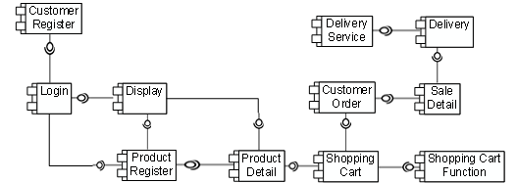

**Chapter 3**

**{Design}**

1. **Structural Model**

**Detailed Class Diagram**



**Detail class definition**

Class Diagram Name: Customer

Attributes: Customer ID, Customer Name, Address, Phone Number, Email

Operations: Register Customer (), Update(), Delete(), View Profile().

The customer class is used to store customer information regarding registration of the system. This allows the customer register and their information. This system access can be deleting and save.

Class Diagram Name: Order

Attributes: OrderID, Order Name, CustomerID, Total Amount, Delivery, Payment Type, Bank Account, Order Address, Phone number, Order status

Operation: Record Order (), Update (), Delete (), View Order (), Confirm Order ()

The Order class is used to store order information regarding registration of the system. This allows the order register and their information. This system access can be update, delete.

Class Diagram Name: Product

Attributes: Operation: ProductID, ProductName, ProductPrice, Image, Quantity, BrandID, CategoryID, Integrity, Description, Ingredient, PromotionID

Operation: Record Product(), Register Product(), Update(), Delete()

The product class is used to store product information regarding registration of the system. This allows the product register and their information. This system access can be delete and save.

Class Diagram Name: Order-Detail

Attributes: OrderID, ProductID, Order Amount, Order Quantity

Operation: Record Order-Detail (), Record Order Amount (), Record Product ()

The Purchase Detail class is used to store Purchase and Product information regarding registration of the system. This allows the Product and Purchase information. This system access can be record, update and delete.

Class Diagram Name: Purchase

Attributes: SupplierID, PurchaseID, Purchase Date, Total amount

Operation: Record Purchase (), Register Purchase (), Update (), Delete ().

The Purchase class is used to store Purchase information regarding registration of the system. This allows the Purchase information. This system access can be record, update and delete.

Class Diagram Name: Purchase Detail

Attributes: ProductID, PurchaseID ,Quantity ,Amount, Price

Operation: Record Supplier(), Record Supplier() , Update(), Delete()

The Purchase Detail class is used to store Purchase and Product information regarding registration of the system. This allows the Product and Purchase information. This system access can be record, update and delete.

Class Diagram Name: Staff

Attributes: Staff ID, Start Name, NRC, DOB, Address, Phone number, Email, Skill

Operation: Record Staff(), Update(), Delete()

The Staff class is used to store staff information regarding registration of the system. This allows the staff information. This system access can be record, update and delete.

Class Diagram Name: Delivery-Detail

Attributes: Recommend, DeliveryID, OrderID

Operation: Record Deli-Detail(), Update(), Delete()

The Delivery-detail class is used to store delivery-detail information regarding registration of the system. This allows the delivery-detail information. This system access can be record, update and delete.

Class Diagram Name: Brand

Attributes: Brand ID, Brand Name

Operation: Record Brand(), Update(), Delete()

The Brand class is used to store Brand information regarding registration of the system. This allows the brand information. This system access can be record, update and delete.

Class Diagram Name: Category

Attributes: CategoryID, Category Name

Operation: Record Product(), Register Product(), Update(), Delete()

The category class is used to store category information regarding registration of the system. This allows the category information. This system access can be record, update and delete.

Class Diagram Name: Purchase

Attributes: Purchase Part ID, Purchase Name, Purchase Date, Purchase Price, Total amount, Supplier ID

Operation: Record Purchase(), Update(), Delete()

The Purchase class is used to store Purchase information regarding registration of the system. This allows the Purchase information. This system access can be record, update and delete.

Class Diagram Name: Supplier

Attributes: Supplier ID, Supplier Name, Address, Email

Operation: Record Supplier(), Update(), Delete()

The Supplier class is used to store Supplier information regarding registration of the system. This allows the Supplier information. This system access can be record, update and delete .

Class Diagram Name: Delivery

Attributes: Deliveries, Delivery Name, Date, Transportation Type, Transportation Info, Charges

Operation: Register Delivery(), Update(), Delete(), View Delivery()

The delivery class is used to store delivery information regarding registration of the system. This allows the delivery information. This system access can be record, update and delete .

Class Diagram Name: Promotion

Attributes: PromotionID, Promotion Name, Start Date, End Date, Percent, Status,

Operation: Record Promotion(), Update(), Delete()

The promotion class is used to store promotion information regarding registration of the system. This allows the promotion information. This system access can be record, update and delete .

1. **Behavioral Models (Sequence Diagram**)



**Customer**

When customer login the webpage, the webpage check the customer’s information in database, If customer’s have account, he can get to display page and can buy the products. If he didn’t account, webpage ask to register. If customer didn’t want to buy products, click logout button. If he want to buy click add to cart button and webpage check the database. Products are in stock customer can buy products and make payment. If the products are out of stock customer can’t buy product



**Staff**

When products are out of stock, admin needs to fill the products, these products are stored in database. To make these process, admin need to login the page. Add products and these products are stored in database. If he wants to add new products, then get products page and the data will store in database.

**Chapter 4**

**{Risk Management and Configuration Management}**

1. **Risk Management**

**Critical Success Factors of a project**

The project requires manager, budget, schedule, risk management, proper project planning, collaborative, communication, documented project. Project requires project manager to support management for top level management when project fail. Project manager supposed to support overview functions to the project team. Project require budget to support throughout the project to complete project in past. Project require schedule to limited time for project. Project requires risk management for project, if risks ignore, can be fail project. By pre identifying risks to help to protect from project fail and reduce from project fail.

To get a successful project, right people with right skills must involve in a project and need to have teamwork in every single one who involve in a project. Need to collect the requirements effectively to develop this project and discuss with customer what the customer wants is so need to have communicate skills to discuss well. Then make plan for the whole project such as define the task for every single one who involve in this project and define priority for tasks and manage that person well when developing the project and make time scope to achieve the small goals in project. Project manager should check the project frequently to achieve the successful project. To attract the customer with fantastic looks and make easy user interface as much as when using customer to use this project is the one important fact to get a successful project.

Project requires proper project plan for project success, without project planning, can be fail. Project require collaborative for project success, if team members develop collaboratively the project, can be easy develop and have good quality, easy in monitoring each team members and can be monitored, plan the complex project by collaboration. Project requires communication. Communication is one of the most important parts for every step and role. All member and stakeholder communicate in developing the project, all project team member need good communication skills. Project requires documented the entire project. Top level manager can be known current develop and can be easy explain in meeting and can be easy identify current project. By doing record documented, can be refer to the responsible project. Risks and management plan can be record in document. In doing project documented is critical success factor of the project.

**Major Sources of Risk**

* **Environmental – unreasonable customer**

The main problem of the environmental risk is the wet weather and being water in the coil packed, when carry coil to the industry, this coils can be rust so that can be lose. This risk are protected by doing such as not deliver this coil in the rainy season and not place this coil the wet place and near the water. And current exchange rate changes, can be lose so that when current exchange low, order and cash this coil from the other country. When electric machine off because drain of energy so that can be lose and delay in the industry. These risks protect by giving the duty to the staff. Environmental risk may become if the fire case become, the software house has no fire preventers and they know the fire case lately, they can lose their valuables materials such as computers, hard disk, their customer information and their finance data if they do not back up the data on other place.

Therefore, they can lose their ongoing project and they can become problems with customer for ongoing project. The property and data steal by staff is another risk. If the staff is, steal the property such as computers, they can lose detention data from that computer if that data did not make back up so the project is delay and not finish in right time scope. If the staff is, steal the company data, sell that data for another company, they can lose their opportunity, and lose reliable from customers. That is the some environmental risk in project. Environmental factors are too dangerous for programmer to complete the projects. For example, if there were fired near the programmer’s house, he must need to run away from fire. Programmer need to carry back up data files with him. This can help when programmer’s home was fired and his PC or Laptop which is writing program has been destructed, he can still write the program anywhere there have a computer. But if he didn’t make back up files or forgot to carry back up file, he can’t write the program.

Another environment issues are natural disasters. These can affect the programmer’s times to finish the program. There have some issues like electricity. Programmer can’t do project without electricity. His PC needs electricity to run and make project. But he can still continue his project if he has laptop or notebook if there have project files and battery was charged.

* **Process / Management**

Analyst analyze the information false for the business so that this project can be many lose that is not good the analyst skill. In changing from the manual system to the computerize system that can be risk. In training, the trainer train to the staff. If this staff is technical weak, difficult to train, After finish the project, testers is testing the program, and pay that program to customer, did not solve the all error because of not finish according to time box. So, they lack the integration testing and pay the customers quickly. Then, the customer start using, at that time, the program become error such as program cannot run and can run but an error found. In doing management, need to identify and analyze the risks and plan by the analyst and manager. If do identify and plan the process and risks, that is to help all of the project life cycle else can be difficult and abandonment the project. Therefore, software house can cause problems with customer and customers can reduce reliable over software house and can reduce next customers. How to protect this risks, want to analyze similar project and documented the plan and identify and listing the plan of the procedure and use to draw project plan software and Gantt Carts, risk control cycle. Need to use demonstrate control, easy to modify existing project.

* **Inadequate control**

The project can be inadequate throughout the project life that is one part of the risks. Sometime user request to set up reply new functions to the manager. The manager must think about this new function, can be get benefit how much quality and time performance and improve budget and improve staff skills and can be what risks. And then discuss owner. This is the risks by being inadequate so that how to protect this risks, must do identify and plan this problem and must identify how to solve this problem and must do to update and modify and delete since the program launch for the project. If set up the new functions for the program so that can be lose budget and time to update the programmer, want to analyze detail information about the functions. And if cause other inadequate risk, must be plan about the adequate control plan regarding the realist working by doing analyze responsible all of the information for the project and must be pre identify potential risks and point out exceptions risks and in control planning, each process is objective determination so that must be objective rather than the subjective and must be identify the control system is operate economically and flexible.

* **Problem and errors detected late**

Problems and errors detected late is such a major risk for programmers. If he needs to give project tomorrow, some errors are found that night, he didn’t enough time to fix the errors. But he can make it, if errors are easy to fix. But if can’t fix, he will lose trust from customers and this can make him to change his job. If he was doing in company he can lost his job. This can affect other programmers who are work together with him. This is because customers will think only about the company, not the programmer who was made mistake. This is really dangerous for company and programmers.

* **Inadequate technical approaches**

If programmer didn’t have adequate technical approaches, he can’t make anything about the project. While processing the project, the programmers cannot choose the suitable language, so can cause many error and the program processing can delay. Another risk is when all the system is finish, but customers want to add the new requirements so need to add the new functions is may be confuse for programmers because each system is connect with each other. Virus attacking is another risk. If the data did not make the backup, all the data can lose when virus attack. It is all the possible technical risk.

**Personal**

* **Wrong Grade**

When the trainer train the staff, can be risks. When make use the computer system to the staff from the production industry, can be difficult to use for the staff, this staff morale can be weak for the changing and when change from the manual system to the computerize system, although this staff is expert in the manual system, can be many difficult to use computer system by the staff that is not lose the staff skill, can be staff morale is bad. The trainer must train this staff to begin train computer basic. It means the one who give by trained ; their level is not qualified, such as they are not too friendly with computers, so their level is too low so, if train them, need to teach from basic can delay the program. When the trainer train the staff from the other department. This staffs can be losing interest for the training, if been that can be lose for the project.

* **Wrong Training**

Training is very important for the project. When the trainer too late to train to the trainer room. The trainer skill is bad and when the trainer train the staff, the presentation skills of the trainer is not good to interest for the trainee and the trainer not know clearly the lessons that is to train when the trainee ask any questions to the trainer, cannot be reply answer to the trainee by the trainer. And sometimes, when the trainer can be false lessons and modules which is to train to the trainee by the trainer. So that can be causing these risks.

* **Wrong Expertise**

The establishment of the team members is one part of the importance for developing the project. Sometimes in establish a team, can be risks. It means that the one who give by trained is not match up training title and their personal skills or they are not qualified on their position.When team members have not the commitment and responsibility for their jobs and sometime, team member skills not fit with their jobs. Team members not interest in their job so that can be failure for the project and abandonment the project. If team member has not collaborative, can be risk if after the project finish, cannot get the good quality project.

* **Too many/few people**

If there are not sufficient people, the company shouldn’t receive the jobs. This can be made programmers to unfinished the jobs for the finish date. If there have too many people, they can’t divide the jobs because the job offer is too small for them, It means that it the staff training is too few when train, it can cause problem because if the staff is quit the work but did not make the backup staff, it can face the delay the program.

**Technical Risk**

* **Requirement Changes**

If the customers change the requirements frequently**,** the software house can face the many issue likes the project finish time can late, the requirement need to recollect again so need more time and cost. Moreover, define the MOSCOW priority frequently. So, the project can delay and project developing time is long so the project cannot finish in time.

* **Failure to meet requirement**

There can be a risk if the program can’t meet requirement. The program will stop when it is running. If this process will occur in business process, the company will get some issues and can get some difficult to end the process. If the development teams do not care the customer’s requirement carefully, they can face problems as they can meet failure result. The customer expectation requirement is not match with their actual result, so customers can get annoy and they can lose their opportunities and can damage company image.

* **Problem Error Detected – inconsistent Design, missing component, inadequate time for testing**

There will get some difficult for business and people if there have inconsistent design. They know nothing when the interface of the website is complex. There may be a risk if there have missing component, For example, customers can’t make check out if there is missing check out button, customer can’t buy anything from website. This can be a major risk for company. If the program does not have time for testing error, it can get annoying for customer. So, need to plan for testing, if one system is finish, should test that one system. Therefore, project can finish in time, errors can clear, and customer can get fulfillment. Therefore, project manager should make the plan for testing carefully.

1. **Risk Matrix**

**(Low= <30%, Medium= >30% and <75%, High=>75%)**

|  |  |  |  |  |  |
| --- | --- | --- | --- | --- | --- |
| **Title and description** | **Risk Status** | **Potential impact** | **Risk owner** | **Actions** | **Action Log** |
| Environmental – unreasonable customer | Low | Medium | Aung Min Myat | Programmer need to backup data files | F-0001 |
| Process/Management | Low | Medium | Aung Min Myat | Programmer need to check errors. | F-0002 |
| Inadequate control | Low | Medium | Aung Min Myat | Programmer need to know about the project. | F-0002 |
| Problem and errors detected late | Low | Medium | Aung Min Myat | Programmer need to check errors. | F-0003 |
| Inadequate technical approaches | Low | Medium | Aung Min Myat | Programmer need to get jobs which can be made by his software. | F-0004 |
| Wrong Grade | Low | Low | Aung Min Myat | Programmer need to know about customer’s row in business | F-0005 |
| Wrong Training | Low | Medium | Aung Min Myat | Programmer need to train right staff | F-0006 |
| Wrong Expertise | Low | Medium | Aung Min Myat | Programmer need to expect his row. | F-0007 |
| Too many/few people | Low | Low | Aung Min Myat | Programmer needs sufficient people for job done. | F-0008 |
| Failure to meet requirement | Low | Medium | Aung Min Myat | Programmer need to know about the requirement. | F-0009 |
| Problem Error Detected – inconsistent Design, missing component, inadequate time for testing | Medium | Medium | Aung Min Myat | Programmer need to be careful not to forget the component. | F-0010 |

## Configuration Management

## Program – Directory Structure

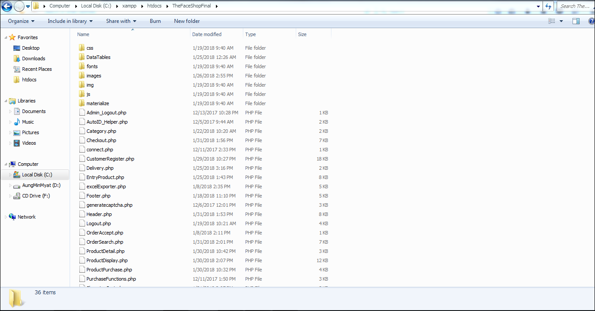

The file location is “This PC > Local Disk (C:) > xampp > htdocs > TheFaceShopFinal”

1. **Documentation – Directory Structure**

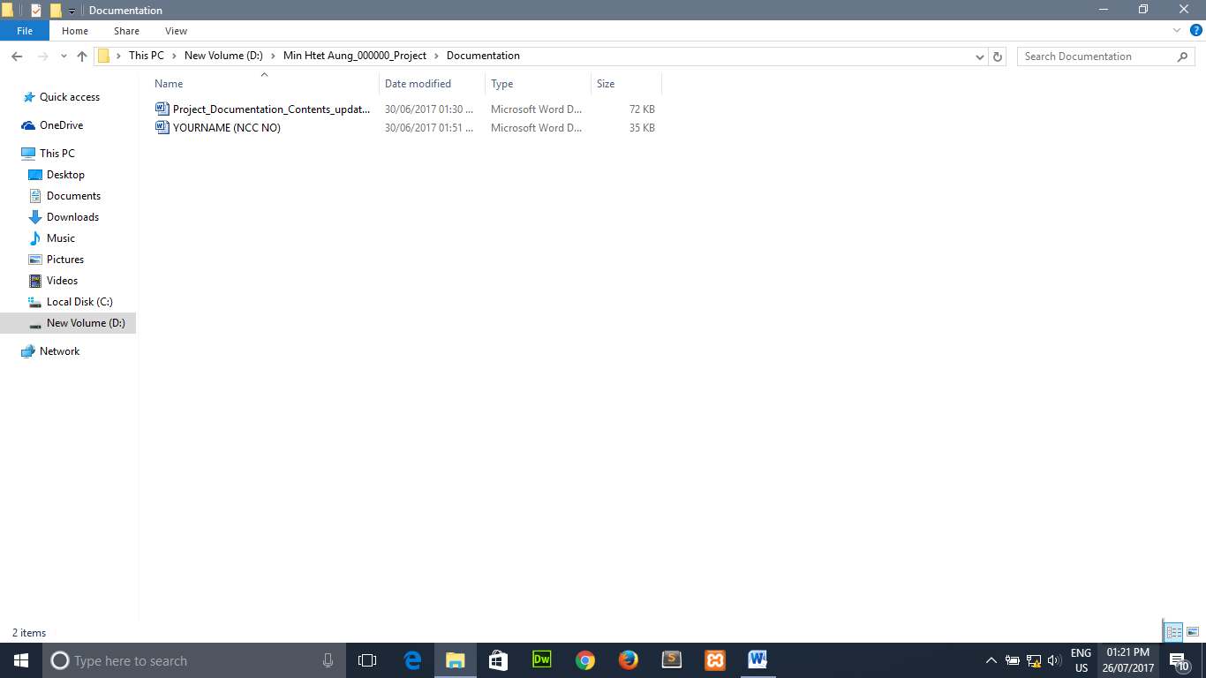

The file location is “This PC > Local Disk (D;) > Aung Min Myat_00172734_Project > Documentation”

**Chapter 5**

**{Testing}**

Module 1: Customer Register

|  |  |  |  |
| --- | --- | --- | --- |
| **Test Case** | **Description** | **Date** | **Tester** |
| 1.1 | Test customer Name text box | 26- December- 2017 | Aung Min Myat |
| 1.2 | Test customer email text box | 26- December- 2017 | Aung Min Myat |
| 1.3 | Test customer phone number text box | 26- December- 2017 | Aung Min Myat |
| 1.4 | Test Customer address text box | 26- December- 2017 | Aung Min Myat |
| 1.5 | Test Customer Password text box | 26- December- 2017 | Aung Min Myat |
| 1.6 | Test customer register button | 26- December- 2017 | Aung Min Myat |

**Test Script**

|  |  |  |  |  |
| --- | --- | --- | --- | --- |
| **Unit Test 1** | | **Test Case : Customer registration by data entry customer** | **Designed by: Aung Min Myat** | |
| Data Source: customer registration Form | | Objective: To test fill text box or not fill in the registration form of data entry customer | Tester: Aung Min Myat | |
| Test Case | Description | Test Procedure | Expected Result | Actual Results |
| 1.1 | Testing the complete registration form of data entry customer | Not fill customer name in the text box and show error message | Show Please fill out this field | See Fig.1.1 |
| 1.2 | Testing the complete registration form of data entry customer | Not fill customer email in the text box and show error message | Show Please fill out this field | See Fig.2.1 |
| 1.3 | Testing the complete registration form of data entry customer | Not fill customer phone in the text box and show error message | Show Please fill out this field | See Fig.3.1 |
| 1.4 | Testing the complete registration form of data entry customer | Not fill customer address in the text box and show error message | Show Please fill out this field | See Fig.4.1 |
| 1.5 | Testing the complete registration form of data entry customer | Not fill customer password in the text box and show error message | Show Please fill out this field | See fig.5.1 |
| 1.6 | Testing the complete registration form of data entry customer | Test click register button and show successful message or error message and already exist. | After full fill in the text box in registration form and not fill in the text box in the registration form and equal email and password in the database then click register button | See Fig.6.1  See Fig.7.1  See Fig.7.2 |

Module 2: Customer Login

|  |  |  |  |
| --- | --- | --- | --- |
| **Test Case** | **Description** | **Date** | **Tester** |
| 1.1 | Test customer email in text box in the customer login form | 26- December- 2017 | Aung Min Myat |
| 1.2 | Test customer password in text box in the customer login form | 26- December- 2017 | Aung Min Myat |
| 1.3 | Test customer login button | 26- December- 2017 | Aung Min Myat |

**Test Script**

|  |  |  |  |  |
| --- | --- | --- | --- | --- |
| Data Source: customer login Form | | Objective: To test fill text box or not fill in the customer login form of data entry customer | Tester: Aung Min Myat | |
| Test Case | Description | Test Procedure | Expected Result | Actual Results |
| 1.1 | Testing the complete and real email and password in the customer login form of data entry customer | Not fill customer email in the text box and show error message | Show Please fill out this field | See Fig.1.1 |
| 1.2 | Testing the complete and real email and password in the customer login form of data entry customer | Not fill customer password in the password box and show error message | Show Please fill out this field | See Fig.2.1 |
| 1.3 | Testing the complete and real email and password in the customer login form of data entry customer | Click login button and show successful message and show email and password incorrect message | Fill registration email and password in the customer login form and click login button and then show successful message and fill not registration email and password and then show password incorrect message and arrive replay login form | See Fig 3.1  See Fig 3.2  See Fig 4.1  See Fig 4.2 |

Module 3: Staff

|  |  |  |  |
| --- | --- | --- | --- |
| **Test Case** | **Description** | **Date** | **Tester** |
| 1.1 | Test Staff Name text box | 26- December- 2017 | Aung Min Myat |
| 1.2 | Test Staff email text box | 26- December- 2017 | Aung Min Myat |
| 1.3 | Test Staff phone number text box | 26- December- 2017 | Aung Min Myat |
| 1.4 | Test Staff address text box | 26- December- 2017 | Aung Min Myat |
| 1.5 | Test Staff Password text box | 26- December- 2017 | Aung Min Myat |
| 1.6 | Test Staff register button | 26- December- 2017 | Aung Min Myat |

**Test Script**

|  |  |  |  |  |
| --- | --- | --- | --- | --- |
| Unit Test 1 | | Test Case : Staff Registration by data entry customer | Designed by: Aung Min Myat | |
| Data Source: Staff registration Form | | Objective: To test fill text box or not fill in the registration form of data entry Admin | Tester: Aung Min Myat | |
| Test Case | Description | Test Procedure | Expected Result | Actual Results |
| 1.1 | Testing the complete registration form of data entry Admin | Not fill Staff name in the text box and show error message | Show Please fill out this field | See Fig.1.1 |
| 1.2 | Testing the complete registration form of data entry Staff | Not fill Staff email in the text box and show error message | Show Please fill out this field | See Fig.2.1 |
| 1.3 | Testing the complete registration form of data entry Staff | Not fill Staff phone in the text box and show error message | Show Please fill out this field | See Fig.3.1 |
| 1.4 | Testing the complete registration form of data entry Staff | Not fill Staff address in the text box and show error message | Show Please fill out this field | See Fig.4.1 |
| 1.5 | Testing the complete registration form of data entry Staff | Not fill Staff password in the text box and show error message | Show Please fill out this field | See fig.5.1 |
| 1.6 | Testing the complete registration form of data entry Staff | Test click register button and show successful message or error message and already exist. | After full fill in the text box in the registration form and not fill in the text box in the registration form and equal email and password in the database then click register button | See Fig.6.1  See Fig 6.2  See Fig.7.1  See Fig.7.2  See Fig.7.3 |

Module 4: Staff Login

|  |  |  |  |
| --- | --- | --- | --- |
| **Test Case** | **Description** | **Date** | **Tester** |
| 1.1 | Test Staff email in text box in the Staff login form | 26- December- 2017 | Aung Min Myat |
| 1.2 | Test Staff password in text box in the Staff login form | 26- December- 2017 | Aung Min Myat |
| 1.3 | Test Staff login button | 26- December- 2017 | Aung Min Myat |

**Test Script**

|  |  |  |  |  |
| --- | --- | --- | --- | --- |
| Data Source: Staff login Form | | Objective: To test fill text box or not fill in the Staff login form of data entry Staff | Tester: Aung Min Myat | |
| Test Case | Description | Test Procedure | Expected Result | Actual Results |
| 1.1 | Testing the complete and real email and password in the Staff login form of data entry Staff | Not fill Staff email in the text box and show error message | Show Please fill out this field | See Fig.1.1 |
| 1.2 | Testing the complete and real email and password in the Staff login form of data entry Admin | Not fill Staff password in the password box and show error message | Show Please fill out this field | See Fig.2.1 |
| 1.3 | Testing the complete and real email and password in the Staff login form of data entry Staff and after being successful login, arrive home page | Click login button and show successful message, arrive home page and show email and password incorrect message | Fill registration email and password in the Staff login form and click login button and arrive home page and then show successful message and fill not registration email and password and then show password incorrect message and arrive replay login form | See Fig 3.1  See Fig 3.2  See Fig 3.3  See Fig 4.1  See Fig 4.2 |

Module 4: Supplier Register

|  |  |  |  |
| --- | --- | --- | --- |
| **Test Case** | **Description** | **Date** | **Tester** |
| 1.1 | Test supplier name in the text box in the supplier registration form | 30- December- 2017 | Aung Min Myat |
| 1.2 | Test country name in the text box in the supplier registration form | 30- December- 2017 | Aung Min Myat |
| 1.3 | Test supplier email in the text box in the supplier registration form | 30- December- 2017 | Aung Min Myat |
| 1.4 | Test phone in the text box in the supplier registration form | 30- December- 2017 | AungMin Myat |
| 1.5 | Test company address in the text box in the supplier registration form | 30- December- 2017 | Aung Min Myat |
| 1.6 | Test register button in the supplier registration form | 30- December- 2017 | Aung Min Myat |

**Test Script**

|  |  |  |  |  |
| --- | --- | --- | --- | --- |
| Data Source: Supplier registration Form | | Objective: To test fill text box or not fill in the supplier registration form of data entry supplier | Tester: Aung Min Myat | |
| Test Case | Description | Test Procedure | Expected Result | Actual Results |
| 1.1 | Testing complete text box in the registration form of data entry supplier | Not fill supplier name in the text box and show error message | Show Please fill out this field | See Fig.1.1 |
| 1.2 | Testing complete text box in the registration form of data entry supplier | Not fill country name in the text box and show error message | Show Please fill out this field | See Fig2.1 |
| 1.3 | Testing complete text box in the registration form of data entry supplier | Not fill supplier email in the text box and show error message | Show Please fill out this field | See Fig 3.1 |
| 1.4 | Testing complete text box in the registration form of data entry supplier | Not fill supplier phone in the text box and show error message | Show Please fill out this field | See Fig4.1 |
| 1.5 | Testing complete text box in the registration form of data entry supplier | Not fill supplier Address in the text box and show error message | Show Please fill out this field | See Fig5.1 |
| 1.6 | Testing registration buton | After Filling supplier registration form and click register button, after filling registration form and click register button | After filling registration form and show successful message, listing and show error message | See Fig 6.1  See fig 6.2  See Fig 6.3  See Fig 6.4  See Fig 7.1  See Fig 7.2  See Fig 7.3 |

Module 5: Purchase

|  |  |  |  |
| --- | --- | --- | --- |
| **Test Case** | **Description** | **Date** | **Tester** |
| 1.1 | Test supplier name in the text box in the supplier registration form | 30- December- 2017 | Aung Min Myat |
| 1.2 | Test country name in the text box in the supplier registration form | 30- December- 2017 | Aung Min Myat |
| 1.3 | Test supplier email in the text box in the supplier registration form | 30- December- 2017 | Aung Min Myat |
| 1.4 | Test phone in the text box in the supplier registration form | 30- December- 2017 | Aung Min Myat |
| 1.5 | Test company address in the text box in the supplier registration form | 30- December- 2017 | Aung Min Myat |
| 1.6 | Test register button in the supplier registration form | 30- December- 2017 | Aung Min Myat |

**Test Script**

|  |  |  |  |  |
| --- | --- | --- | --- | --- |
| Data Source: Supplier registration Form | | Objective: To test fill text box or not fill in the supplier registration form of data entry supplier | Tester: Aung Min Myat | |
| Test Case | Description | Test Procedure | Expected Result | Actual Results |
| 1.1 | Testing complete text box in the registration form of data entry supplier | Not fill supplier name in the text box and show error message | Show Please fill out this field | See Fig.1.1 |

Module 6: Products Register

|  |  |  |  |
| --- | --- | --- | --- |
| **Test Script** | **Description** | **Date** | **Tester** |
| 3.1 | Verify that the input field doesn’t accept null value. | 22- Jun- 2017 | Aung Min Myat |
| 3.2 | Verify that the register products are stored in data base. | 22- Jun- 2017 | Aung Min Myat |
| 3.3 | Verify that the update products are stored in database. | 22- Jun- 2017 | Aung Min Myat |
| 3.4 | Verify that product is deleted in database. | 22-Jun-2017 | Aung Min Myat |

**Test Script**

|  |  |  |  |  |
| --- | --- | --- | --- | --- |
| Data Source: Product Form | | Objective: To test fill text box or not fill in the product form of data entry product. | Tester: Aung Min Myat | |
| Test Case | Description | Test Procedure | Expected Result | Actual Results |
| 3.1 | Verify that the Maker field doesn’t accept null value. | Don’t fill the Maker and click the register button | Show Please fill out this field | See Fig.1.1 |
| 3.2 |  |  |  |  |
| 3.3 |  |  |  |  |
| 3.4 |  |  |  |  |

Module 7: Register Category

|  |  |  |  |
| --- | --- | --- | --- |
| **Test Script** | **Description** | **Date** | **Tester** |
| 4.1 | Verify that the input field doesn’t accept null value. | 22- Jun- 2017 | Aung Min Myat |
| 4.2 | Verify that the register categories are stored in database. | 22- Jun- 2017 | Aung Min Myat |
| 4.3 | Verify that the input field doesn’t accept null value. | 22- Jun- 2017 | Aung Min Myat |
| 4.4 | Verify that the update categories are stored in database. | 22- Jun- 2017 | Aung Min Myat |
| 4.5 | Verify that deleted categories are deleted in database. | 22- Jun- 2017 | Aung Min Myat |

**Test Script**

|  |  |  |  |  |
| --- | --- | --- | --- | --- |
| Data Source: Category | | Objective: To test fill text box or not fill in the category form of data category. | Tester: Aung Min Myat | |
| Test Case | Description | Test Procedure | Expected Result | Actual Results |
| 4.1 | Verify that the input field doesn’t accept null value. | Don’t fill the Maker and click the register button | Show Please fill out this field | See Fig.1.1 |
| 4.2 | Verify that the register categories are stored in database. |  |  |  |
| 4.3 | Verify that the input field doesn’t accept null value. |  |  |  |
| 4.4 | Verify that the update categories are stored in database. |  |  |  |
| 4.5 | Verify that deleted categories are deleted in database. |  |  |  |

Module 8: Order

|  |  |  |  |
| --- | --- | --- | --- |
| **Test Script** | **Description** | **Date** | **Tester** |
| 8.1 | Check the confirm button is work in web page. | 4- Jul- 2017 | Aung Min Myat |
| 8.2 | Check that show all button is works. | 4- Jul- 2017 | Aung Min Myat |
| 8.3 | Check that admin can search products with dates. | 4-Jul-2017 | Aung Min Myat |
| 8.4 | Check that admin can search products with customer’s name | 4-Jul-2017 | Aung Min Myat |
| 8.5 | Check that admin can search products with product names. | 4-Jul-2017 | Aung Min Myat |

**Test Script**

|  |  |  |  |  |
| --- | --- | --- | --- | --- |
| Data Source: Order Form | | Objective: To test fill text box or not fill in the order form of data order entry. | Tester: Aung Min Myat | |
| Test Case | Description | Test Procedure | Expected Result | Actual Results |
| 1.1 | Verify that the Maker field doesn’t accept null value. | Don’t fill the Maker and click the register button | Show Please fill out this field | See Fig.1.1 |
|  |  |  |  |  |
|  |  |  |  |  |
|  |  |  |  |  |
|  |  |  |  |  |

Module 9: Purchase

|  |  |  |  |
| --- | --- | --- | --- |
| **Test Script** | **Description** | **Date** | **Tester** |
| 9.1 | Check the add button is work. | 19- Jul- 2017 | Aung Min Myat |
| 9.2 | Check the purchase button is work. | 19-Jul-2017 | Aung Min Myat |
| 9.3 | Check that remove button is work. | 19-Jul-2017 | Aung Min Myat |

**Test Script**

|  |  |  |  |  |
| --- | --- | --- | --- | --- |
| Data Source: Purchase | | Objective: To test fill text box or not fill in the purchase of data purchase. | Tester: Aung Min Myat | |
| Test Case | Description | Test Procedure | Expected Result | Actual Results |
| 1.1 | Verify that the Maker field doesn’t accept null value. | Don’t fill the Maker and click the register button | Show Please fill out this field | See Fig.1.1 |
|  |  |  |  |  |
|  |  |  |  |  |

Module 10: Delivery

|  |  |  |  |
| --- | --- | --- | --- |
| **Test Script** | **Description** | **Date** | **Tester** |
| 10.1 | Check that admin can search the customer’s order with date. | 19- Jul- 2017 | Aung Min Myat |
| 10.2 | Admin can search delivered products with date. | 19-Jul-2017 | Aung Min Myat |

**Test Script**

|  |  |  |  |  |
| --- | --- | --- | --- | --- |
| Data Source: Order Form | | Objective: To test fill text box or not fill in the order form of data order entry. | Tester: Aung Min Myat | |
| Test Case | Description | Test Procedure | Expected Result | Actual Results |
| 1.1 | Verify that the Maker field doesn’t accept null value. | Don’t fill the Maker and click the register button | Show Please fill out this field | See Fig.1.1 |
|  |  |  |  |  |

**Chapter 6 {Implementation}**

* 1. **Deployment Diagram (Implementation)**



**Description**

Staff team install window 10 (64 bits) OS for client to use the web site and other things. Staff team install famous browser such as Google Chrome, Mozilla Firefox. Client need to use these browsers to run use the website. To protect data and some virus, admin team installs some antivirus software. Customer’s orders will store in database named face shop. The domain name is face shop. To print out the customer’s order, admin team use Cannon printer.

1. **Data Migration**

Data Migration is the procedure of shifting data from one system to another while changing the storage, database or application. There are several reasons to carry out data migration project such as replacing or upgrading servers or storage equipment, moving data to third-party cloud providers, website consolidation and infrastructure maintenance. Data Migration is transferring the old data from old stuff to new stuff. If u upgrade, implement or combination of data from any system, data migration is the most appropriate. A data migration project is performed for the number of reasons, including replacing or improving the server or storage device, move data to an external cloud provider, without consolidating, maintaining infrastructure, application migration or database, improve the software, company mergers or relocation of data centers. To get a effectual data migration process, the old system of data is mapped to the new system from data extraction and data loading. Data Migration is process which is changing the file formats to computerize system. Data migration usually use to freeing up human tasks which are boring. Data migration usually used to replace server or storage equipment, maintenance or updates, application migration and datacenter relocate.

The data transfer between the types of computer storage or file format of the data transfer process. This is not a system for implementation, upgrade, or consolidation is a key consideration.

* We are calling the one data migration term.
* 25% of company staffs use in the data migration.
* Teach the 25% company staffs for date migration.

|  |  |  |  |  |  |  |
| --- | --- | --- | --- | --- | --- | --- |
| **No.** | **Task** | **Task Description** | **Start Date** | **End Date** | **Key Responsible Person** | **Dependency** |
| 1 | Data input to the system |  | 12/7/2017 | 15/7/2017 | Entry Staff |  |
| 2 | Make recordings between the destination system and the source system fields |  | 15/7/2017 | 19/7/2017 | Management level staff | After no.1 |
| 3 | Master Data |  | 19/7/2017 | 23/7/2017 | Entry Staff | After no.2 |
| 4 | Transactional Data |  | 23/7/2017 | 26/7/2017 | Entry Staff | After no.3 |
| 5 | Match Migrated Records to Records Generated by the Destination System |  | 26/7/2017 | 30/7/2017 | Management  level staff | After no.4 |
| 6 | Running data migration |  | 30/7/2017 | 3/8/2017 | Management level staff | After no.5 |
| 7 | Cleanings to data (elimination obsolete, removal of duplicate, correct inaccurate, correct incomplete record) |  | 3/8/2017 | 6/8/2017 | Entry Staff | After no.6 |

1. **Training**

|  |  |
| --- | --- |
| **Training Title** | **Login** |
| Type of User | All HR staffs including data entry staffs as well as the management level ones |
| Location | Hoping Star Health Services |
| Date | February 10, 2015 |
| Time | 9:00 am to 10:00 am |
| Tool | PC on which the program is installed |
| Description | How to log in to the system and the passwords and user names for each user group |

|  |  |
| --- | --- |
| **Training Title** | **Login** |
| Type of User | All HR staffs including data entry staffs as well as the management level ones |
| Location | ND Travel and Tours |
| Date | February 1, 2018 |
| Time | 11:00 am to 12:00 am |
| Tool | PC on which the program is installed |
| Description | How to log in to the system and the passwords and user names for each user group |

|  |  |
| --- | --- |
| **Training Title** | **All of Entry Form** |
| Type of User | All HR staffs including data entry staffs as well as the management level ones |
| Location | ND Travel and Tours |
| Date | February 2, 2018 |
| Time | 10:00 am to 2:00 am |
| Tool | PC on which the program is installed |
| Description | How to entry the data in to the system |

|  |  |
| --- | --- |
| **Training Title** | **All of Update and Delete Form** |
| Type of User | All HR staffs including data entry staffs as well as the management level ones |
| Location | ND Travel and Tours |
| Date | February 3, 2018 |
| Time | 10:00 am to 2:00 am |
| Tool | PC on which the program is installed |
| Description | How to update and delete the data in to the system |

**Training schedule of operational level**

|  |  |  |  |  |
| --- | --- | --- | --- | --- |
| Module Name | Training date | User level | Location | Trainer |
| Registration form | 1/10/2017 | Team leader and staff | The Face Shop  Cosmetics Center | Aung Min Myat |
| Log in form | 4/10/2017 | Manager and  staff | The Face Shop  Cosmetics Center | Aung Min Myat |
| Purchase form | 9/10/2017 | Staff | The Face Shop  Cosmetics Center | Aung Min Myat |
| Payment system | 13/10/2017 | Staff | The Face Shop  Cosmetics Center | Aung Min Myat |
| Edit and delete any system | 18/10/2017 | Staff | The Face Shop  Cosmetics Center | Aung Min Myat |
| Search and report system | 22/10/2017 | Manager | The Face Shop  Cosmetics Center | Aung Min Myat |

**Chapter 7 {Conclusion}**

**Evaluation**

Aggregate the business performance and getting profit are the main tenacity of developing the website. PHP programming language will be used to develop of the web page. The database system is using MySQL database system because its can ensemble with PHP. Developing for our project will be used of the agile development. For increase developing of our business, the new computerized system may be helped by manually system. Include of the project data; build of the project system is easy to use for staff and customer. Easily by typing in the search box, the customer can search the product that they need brand product. This can save a lot of time. The report can be read faster than before by the business owner. The project business system will kept all of the data entries in the database and this can safe more than store in the paper manually system. This can also easily retrieve and update of the data and require account, the web page design is very simple and no attractive for user. However, can be help for user to use the web page without confusing.

As the first experience of doing Project, had been learnt how to be a project analyst, how to be a business manager, how to be a project manager, how to be a web designer or programmer and how to be a expect tester at the same time. At first, the choice of approach for project flow such as waterfall model approach and agile approach that made the different of project outcomes result. This project is developed by agile approach which process step by step like waterfall model but the difference is that agile have maintaining and reviewing in each step. It became rapid of developing software. It is suitable for short-term project.

The choice of languages is important in developing software. PHP languages can run on open source platform and suitable for student that not cost, can be freely use with MySQL Database. However, if this banking software were the real project and hosted by ISP with domain, MySQL Database not such good to store the information of whole country’s customers. At the stage of Implementation stage, testing is necessary for customer who will use this software to be easy to use and user manual guide is needed which provide how to use this banking step by step.

1. **Evaluation against Aims and Objectives**
2. **Aims and Objectives**

**Aims**

* To change manual system to computerized system
* To increase more customers
* Advertised Products and Give Information Products
* To solve Issues and more get the customers
* To create E-commerce
* To be popular of the business products
* To resolve the problem of the business issues.
* To increase the equities
* To profit for the business

**Objectives**

* To solve the issues to be more functions more additional
* To be more functional and more additional
* First we will add and modified some function
* First we convert the manual to computerized system
* To change the computerized system
* Register permission to create web page.
* Create the website
* Advertise the product and about promotion
* Register the product and customer information
* Register the most sale products from the sale center
* Appoint a dynamic website developer
* Appoint a hardware/software engineer
* Register permission to run e-commerce
* We can be save the data and info thus can be protecting loosing book
* When changing the computerized we need to be many steps
* More customer/Market share: create website, discount

1. **What have been done?**
   * To solve current business issues- For solving current business issues, some of the processes that have issues are changed into computerized system. Xampp, Sublime Text and MySQL database were used in changing computerized system.
   * To get more customers-To complete the aim of getting more customers, the project teams create a web page for The Face Shop Online Store. By creating a web page, The Face Shop Online Store may become more popular in medical field, more people can know about this book center and it can get more customers than earlier.
   * To reduce wasting time-In current business system, customers have to line up to purchase their books. But the project teams make a computerized system for saving time of these customers. It can not only saving customer time but also it can save the time of The Face Shop Online Store staff.
   * Reducing mistakes-Staffs of The Face Shop Online Store can make a mistake during calculating profits, price and producing reports. But there can be no mistake in calculation of computerized system and it is better than manual calculating system. Therefore project team make a computerized calculating system for The Face Shop Online Store
2. **Problems Encountered**
   * Any problem got of the make project.
   * I have no experience of using PHP and MySQL. So I don’t identify how to solve the error and I can’t solution when the error was occurred.
   * It wastes many times for searching the error and learning how to solve the error. This is the first time of making project for me.
   * As of the being first project, do of the project many difficulties and got of the more knowledge.
   * I have a problem of losing my data that is loss of my pc. And I have not backup my data. So I need to start making the project again from the beginning and writing of the data. This problem also wasted my time and I got the experience of to create backup for the data.
   * In the middle of the development time, my computer Windows is down.
   * And I am so lucky at this time because I have a backup data in my memory stick. Because of the first time losing data, I get the experience of backing up the data and I know one thing is we should back up our data while doing the project.
   * When I am doing the project, the weather is rainy season and I was ill while I was analyzing and collecting the business information.
   * So, I take a medicine and take a rest for a weak. I take a rest at home for one week and this make me late in developing a project.
3. **Lesson Learnt**

We know about the selling process of The Face Shop Cosmetics Online Shop. At the analysis stage we know about the current business issues and their problems between staffs and customers. During the programming state, we know about the important roles of collaboration between users and project team or collaboration between mates. And we know about the how important the user requirement. Without knowing anything about user requirement the product will be no valued and we got many experiences. I learnt a lot from this project such as how to write the coding and solve the error. Then how to create the user interface design simply and cool to attract the customer. In addition, how to create the whole website systematically. I knew a lot of business and technical knowledge.

1. **Evaluation against Similar System Comparison**

**Functional comparison**

* Navigation of both websites is fast and no error. Therefore, the navigation of this project must also fast and free errors.
* New account registration of Nature Republic website is containing my account button and it is easy to create or register account. New account registration of eBay website is easy but not easy to find registration or create account button.
* Delivery services are available in both website and this project will also contain delivery services.
* Both of this website can search the book by book type, name of author and name of the books.

**Usability comparison**

* Homepage of eBay website is simple and color is good for users. Homepage of Nature Republic has too many advertisements and color of the home page is good for users. But too many advertisements are complex for user vision.
* Menu of eBay website is familiar, simple and easy to use for users. And menu of Nature Republic online bookstore website is simple and more categories are available for customers but it is complex for user eye sight.
* Colors of both websites are using white background color and black text letters. These colors are good for user eye sight and can read long time. Therefore, color of this project is also with white background color and black text letters.
* In comparison of this both website and, exotic cosmetics interface is attractive and information is accomplished.
* Customer can reliable because website interface is impressive and ease of use.
* This is also connecting with trip advisor so customer can get promotion. is so simple and ease of use.

1. **Evaluation against Justifications Made**
2. **Language**

PHP language was chosen in this project because it very easy and simple to use. It is suitable for all browser and update version of descripting languages. In this project, I used PHP to develop the project. PHP speed rate is fast. PHP can use with many relational database management systems available on all known and available servers for many different operating systems. Therefore, it is usability. It is relatively quick because it uses multiple system resources. Since then, as the store many developers, so when I found an error, it can be quickly restored. In addition, it can easily connect with database. That’s why I selected these languages.

1. **Problem Encountered**

There are many problems during the using of PHP language. Such as undefined variable index, parse errors, syntax errors and fatal errors, etc. Some of the minor error can be fixed but some of them are fixed by teachers. I faced many problems when developing this project with PHP language. I do not know well about PHP language so I do search about the PHP language on the net and start slowly step-by-step. While developing the program, I faced with many errors. Because of solving this error, I was delay the project and not finish according to time box.

1. **Lessons Learnt**

After using PHP language, knowledge gain such as how to create login page, logout page, product entry, product update and delete and how to make check out page. And also know how to fix the error such as syntax error, parse error and so on. I learnt a lot while developing the project with PHP language. I knew how to create a webpage with PHP code and how to add CSS code in website with PHP code to get cool website. Then, I knew how to find error when errors are occurring.

1. **Database**
2. **Selected Database**

MySQL was chosen for this project because MySQL can be used for multi-platform, MySQL is very fast, reliable and easy to understand, MySQL include sensitive security system to protect unexpected bugs and cost of MySQL is not very expensive. I used MySQL database while developing this program. My SQL works on almost all platforms. It is secured. Most of the big ecommerce website are used My SQL. SQL can retrieve large amount of data record quickly because it has high speed. It is no coding required and inexpensive. It has great performance. And It can join with PHP language. Therefore, I selected MySQL database.

1. **Problem Encountered**

At first, there is many problems in using database. Even difficult to create tables, rolls and columns. The real problem is don’t know how delete the table from database. But it was easy after using friendly with database. The problems is I do not know well about the MySQL database, so I searched the about that database at website and in learn about this. Therefore, many errors occur, time waste and program is delay.

1. **Lessons Learnt**

At the first time of using database I have no idea how to delete the table from database. But after I asked to teacher I know how to delete the table from database. The key is typing coding “drop table name” in SQL. After typing these coding the selected table will be deleted. I have no experience before so I know many things then before. Now, I knew how to develop a database and how to connect the database with program and how to implement the whole project. Moreover, how to insert the data into database. Moreover, I knew that important fact is that MySQL database is one of the usability databases and can easily use with many programming language. That is all.

1. **Methodology**
2. **Selected Methodology**

Agile was used in this project because of user satisfaction, producing right products, can improve team work, flexibility, visibility to team members and customers. This program is developing with Dynamic System Development Method (DSDM) and MOSCOW technique. DSDM is a method includes support incremental development to build completes the project according to deliver true business benefits and iterative development to join perfect business solution. DSDM atern accept the changing situation and can change the requirements every time. In MOSCOW prioritization, requirements is first priorities and need to know the requirements and if do not know the requirements definitely, the project will not work effectively. Therefore, the project cannot deliver to the user on time. That is why MOSCOW prioritization is effective for the project.

1. **Problem Encountered**

The problem of agile methodology is flexibility. Flexibility is one of the strength of the agile methodology but sometime this strength become weakness. Change is important and acceptable but it is not good for every time. There should limitation for changing function of the project. The problem that we faced is I choose the right methodology carefully. Therefore, I search about many methodology and learn carefully. In all of that methodology, this methodology is match with this program and best methodology.

1. **Lesson learnt**

After doing this project, I know the important roles of users, customers and project team member. Important of collaboration, how iteration is work and good points changing. I learned how to choose the right methodology carefully and how to negotiate and respond to change over following plan.

1. Evaluation against Project Plan

* Whether the project is on track with the plan
* What was complete on time
* What was not complete on time and why
* Lessons Learnt

1. **Future Amendments**

**Program**

This project is giving me much experiment and at now I have to know many effects from this. Design web page is very simple and no attractive for the user and In the future, Functionality web page is also no functionality and because of my technical weakness and not only this but also time management weakness and no project experience. Now, I am learning about the technical and the business knowledge from the project. This project gives me a lot of experience. If I can have more time, we want to add more performance. I want to add more process such as payment from bank

Account process, auto send up to date information to customer if customer had sing in into our website. In addition, I want to add more attributes to know customer information to promote according to their data. I want to add more code process to get unique interface.We didn’t enough time to make project. We want to add more functions in our project. But we didn’t enough time to find the codes and have a shot project time, our project is not perfect and we didn’t reach to expected result. We want to make display page more reality. The products are shown only in one page and customers need to scroll down to choose the products. We add search box but some customer want to see the products which they want to buy.

We want to duplicate webpages to show the products. Just 10 products are shown in one page and other products are shown in another page. For example (10 products are shown in page 1 and another products are shown in page 2, page 3 and etc.).We also want to hide forget password link. When customer was wrong the email and password, the forget password link will appear. But we didn’t enough time to find these codes, we add the forget password link below the login box. We want to make customers to update their profile. Customer can add their photo and update their profile picture, phone no and address. We want to add the discount process. When customer buys more than that admin assign, he can get discount. And also we want to record the products which are crushed when arrived from suppliers. This can make easily to change the good products from supplier. We want to make our website can change languages. Customers can change the website language from English to Burmese. This can help customers to understand about the website. Customers who are not good at English language can change the language. This can make easy them to choice the products and understand the how to finish their purchase process.

**Design**

Firstly, I required making the program design unique. The design is not too bad but if I had a little more time I would add more fantastic design.

Secondly, I need to add more features like customer can contact admin from internet, they can view product from internet and they can purchase directly from their bank accounts, everything goes with internet connection.

Thirdly, I want to add more java scripts coding, which makes the program run smoother and easier. They are truly reliable but they are complex to use. Due to its complexity, it is not possible to learn and use them in given time. So, in this program very little java scripts are used. Finally, I will add more function, design and java script coding. I want to afford more test scripts to prove the program’s reliability and hardy. I want to add more unique design such as recreate the user interface with adding more CSS code to attract the customer and get more customers. Then I want to recreate the website design can fit with mobile phone and can use easily in mobile phone. I also want to add more system design unique than other website.

Finally, I will add more function, design and java script coding. I want to afford more test scripts to prove the program’s reliability and hardy.

**Report**

I want to add more security to secure our website and our customer information. I want to protect website data and customer data to protect from hacker so I want to add social and legal Information in website to reliable our website for customer. For example, if someone stole the data, sell that website data to another company; you can be entangled with legal issue. I want to add PEST and SWOT analysis to influence political, economic, sociological, technological factor in project organization. And also want to add ethical issue.

# List of References

*flatworldsolutions.* (2017, july 30). Retrieved from htttp://blog.flatworldsolutions.com

*quora.* (2017, july 30). Retrieved from http://www.quora.com

*rapidprogramming.com.* (2017, july 30). Retrieved from http://www.rapidprogramming,com

Advantages. (2017). *Advantages & Disvantages Similar Product.* Web page: www.advanatgesproduct.com.

Comparison. (2017). *Similar Product.* www.comaprisonproduct.com.

Cosmetic, B. D. (2017). *Beauty Diary.* Korea: www.beautydiary.com.

googlesearch. (10 July,2017). *Google.* www.googlesearch.com.

Group, K. (2017). *Software.*

KMD. (13 July, 2017). *KMD Group Of Companies.* www.kmd.com.mm.

language, p. (18 July,2017). *PHPLanguages.* www.php.com.

Method, A. (16 July,2017). *Agile Method.* www.agilemethod.com.

myanmartelecom. ( 8 July,2017). *MyanmarTelecom.* www.myanmartelecom.com.

MySQL. (20 July,2017). *weaknessMySQL.* www.weaknessofMySQL.com.

Page, B. D. (2017). *Beauty Diary.* Korea: www.beautydiarypage.com.

Product, K. (2017). *Nature Republic.* Korea: www.naturerepublic.com.

**Appendix**

* **Requirements Catalogue**

Functional Requirement

|  |  |  |  |
| --- | --- | --- | --- |
| **ID** | **Name** | **Description** | **Acceptance Criteria** |
| 1 | Register Customer | The customer can create the business account for buy of the product | The customer must to insert their name.ID card number, date of birth, address and phone number, email, password correctly |
| 2 | Record Product | To show the display for customer and record how many products in the business. | Staff should to record the product ID, product name, brand category and product name correctly. |
| 3 | Purchase Product | For the product display, the business should to buy brand cosmetics. Use the product display and customer buy of this brand. | Staff should be record product in the system. How many product purchase and sale product in this business. |
| 4 | Sale Product | The customer can be sale cosmetics with display form the website and make payment from the website. | The customer need to be inserted their own business account and make sale from the website as the customer like. |
| 5 | Make Delivery | After receive the sale, the business should sent the product that the customer order. | The business delivery staff is need to know the route very well and the delivery should too fast and right. |

### Non Functional Requirement

|  |  |  |  |
| --- | --- | --- | --- |
| **ID** | **Name** | **Description** | **Acceptance Criteria** |
| 1 | Record Supplier information | Record the supplier information for knowing which product they sell and how much they sell the product. | The staff should record all the supplier information and report to owner. |
| 2 | Online Payment | The customer will sale product from the website and they should make payment directly from the website. | The Customer can sale product from the website and they should pay 100% charge to the business. |
| 3 | Record Customer Address | The business will make delivery for the product that the customers are order. They will make delivery with the address given by the customer. | The business main system is product sale delivery so the customer should give the correct address. If the customer is from other city, this customer can’t order because the business delivery target area is only Yangon. |
| 4 | User Interface Design | The customer will sale product from the website. The business will have the website that is simple for user. | The mobile business system are simple for customers to sale and make payment. |
| 5 | Sales Report | Record the total amount that sales in one day. 13 numbers of sale report will out in 4 minute from the printer with slip. | The staff should to be made a record which contain how many sale for product in this business receive and total amount that the business receive in one day. |

### Use Case Description

**Use Case 1**

Use case Name: Create Record Product

Actor : Admin

Description : This stage admin create of the product for sale. this data is stored of the product table in the database and use for sale. Product table is first needed of the point of sale system.

**Use Case 2**

Use case Name: Create Record Purchase Product

Actor : Admin

### Description : Record purchase product is only to know admin because his buy of the product and purchase. Admin do of the purchase product and sale of this product.

**Use Case 3**

Use case Name: Create Make Payment

Actor : Admin, Customer

### Description : Admin is purchase of the product and Customer is buying of the product for create make payment. Create make payment is support of the admin and customer.

**Use Case 4**

Use case Name: Create Make Sale

Actor : Admin

### Description `: Create make sale is only used for admin. Admin is used to make sale of the product and customer purchase of the product.

**Use Case 5**

Use case Name: Create Make Delivery

Actor : Admin, Customer

### Description : Create make delivery is used for admin and customer. Admin is delivery of the product for customer. Customer is got of the product for reply.

## Detail Class Definitions

Class Diagram Name : Admin

Attributes : AdminID, AdminName, Password, Phone

Operations : Save(), Delete(), Update()

<< The admin class is used to store information about admin. Admin controls the system of the web site, user accounts and registration products..>>

Class Diagram Name : Product

Attributes : ProductID, CategoeyID, BrandID, Price, Quantity, Description, Path

Operations : Save(), Delete(), Update()

<<Product class is used to store the products which are added by admin. >>

Class Diagram Name : Purchases

Attribute : SupplierID, PurchaseID, ProductName, BrandID, TotalQuantity, TotalAmount

Operations : Save(), Delete(), Update()

<< Purchase class is used to store supplier’s ID, whcich products are bought from that supplier and total amount. >>

Class Diagram Name : Supplier

Attribute : SupplierID, SupplierName, Address, Phone

Operation : Save(), Delete(), Update()

<< Supplier class is used to store the data about the supplier. Supplier are delivered products to the admin.>>

Class Diagram Name : Customer

Attribute : CustomerID, CustomerName, Phone, Useremail, Address, Password, Gender, Status

Operation : Save(), Delete(), Update()

<< Customer class is used to store the data about the customer. Customer buys the product from the website. >>

Class Diagram Name : Order

Attribute : CustomerID, OrdreID, OrderDate, Price, TotalQuantity, TotalAmount

Operation : Save(), Delete(), Update()

<<Order class is used to store the customer’s orders. This class will help to admin to see the customer’s orders. >>

Class Diagram Name : Delivery

Attribute : CustomerID, OrderID, ProductID, Address, DeliveryDate, DeliveryTime

Operation : Save(), Delete(), Update()

<< Delivery class is used to store the delivery date and time. Admin will check this class and deliver products. >>

Class Diagram Name : Payment

Attribute : PaymentID, PaymentType, Amount, Status

Operation : Save(), Delete(), Update()

<< This class is used to store the customer’s payment. Admin can see customer’s payment type, how much did he buy.>>

Class Diagram Name : Brand

Attribute : BrandID, BrandName

Operation : Save(), Delete(), Update()

<< This class is used to store the brand id and brand name. >>

Class Diagram Name : Category

Attribute : CategoryID, CategoryName

Operation : Save(), Delete(), Update()

<< This class is used to store the category of the products. Customers can easily choose the product by using category. >>

### Detail Class Definitions

|  |  |  |  |
| --- | --- | --- | --- |
| File Name : Staff  Primary Key : StaffID  Foreign Key :None | | | |
| Field Name | Type | File Size | Description |
| Admin ID | VARCHAR | 30 | Store of the admin ID |
| Admin Name | VARCHAR | 30 | Store of the Admin Name |
| Email | VARCHAR | 30 | Store of the admin email |
| Password | VARCHAR | 30 | Store of the password for admin |

|  |  |  |  |
| --- | --- | --- | --- |
| File Name : Category  Primary Key : CategoryID  Foreign Key :None | | | |
| Field Name | Type | File Size | Description |
| CategoryID | VARCHAR | 20 | Store of the CategoryID |
| Category Name | VARCHAR | 20 | Store of the Category Name |

|  |  |  |  |
| --- | --- | --- | --- |
| File Name : Customer  Primary Key : CustomerID  Foreign Key :None | | | |
| Field Name | Type | File Size | Description |
| CustomerID | VARCHAR | 30 | Store of the Customer ID |
| Customer Name | VARCHAR | 30 | Store of the Customer Name |
| Gender | VARCHAR | 30 | Store of the Gender for customer |
| Phone | VARCHAR | 30 | Store of the customer phone |
| Address | VARCHAR | 30 | Store of the customer address |
| Email | VARCHAR | 20 | Store of the customer email |
| Password | VARCHAR | 20 | Store of the customer password |

|  |  |  |  |
| --- | --- | --- | --- |
| File Name : Delivery  Primary Key : DeliveryID  Foreign Key :None | | | |
| Filed Name | Type | Filed Size | Description |
| DeliveryID | VARCHAR | 30 | Store of the delivery id |
| Delivery Name | VARCHAR | 30 | Store of the delivery name for delivery staff |
| Delivery Address | VARCHAR | 35 | Store of the delivery address for delivery staff |
| Delivery Phone | VARCHAR | 20 | Store of the delivery phone |

|  |  |  |  |
| --- | --- | --- | --- |
| File Name : PaymentType  Primary Key : PaymentTypeID  Foreign Key : SupplierID , ProductID | | | |
| Filed Name | Type | Filed Size | Description |
| PaymentTypeID | VARCHAR | 20 | Store of the PaymenttypeID |
| SupplierID | VARCHAR | 20 | Store of the SupplierID for join of this table |
| ProductID | VARCHAR | 20 | Store of the ProductID for join of this table |
| Total Amount | INT | 30 | Store of the payment type total amount |

|  |  |  |  |
| --- | --- | --- | --- |
| File Name : Product  Primary Key : ProductID  Foreign Key : BrandID, CategoryID | | | |
| Field Name | Type | Field Size | Description |
| ProductID | VARCHAR | 20 | Store of the ProductID |
| Image | VARCHAR | 300 | Store of the product image |
| Product Name | VARCHAR | 30 | Store of the product name |
| Brand ID | VARCHAR | 20 | Store of the brand id and join of this table |
| Category ID | VARCHAR | 20 | Store of the category id and join of this table |
| SalesPrice | INT | 30 | Store of the product sales price |
| Description | VARCHAR | 60 | Store of the description of this product |
| Size | VARCHAR | 40 | Store of the product size |
| Color | VARCHAR | 30 | Store of the product color |
| Quantity | INT | 30 | Store of the product quatity |

|  |  |  |  |
| --- | --- | --- | --- |
| File Name : Purchase  Primary Key : Purchase ID  Foreign Key : SupplierID | | | |
| Field Name | Type | Field Size | Description |
| PurchaseID | VARCHAR | 15 | Store of the purchase id |
| Purchase Date | INT | DATE | Store of the purchase date |
| SupplierID | VARCHAR | 15 | Store of the supplier id and join of this table |
| Total Amount | VARCHAR | 11 | Store of the total amount for purchase |

|  |  |  |  |
| --- | --- | --- | --- |
| File Name : PurchaseDetail  Primary Key : PurchaseDetailID  Foreign Key : SupplierID | | | |
| Field Name | Type | Field Size | Description |
| PurchaseID | VARCHAR | 15 | Store of the PurchaseID |
| ProductID | VARCHAR | 15 | Store of the Product ID for join of this table |
| Quantity | INT | 11 | Store of the purchase detail quantity |
| Price | INT | 11 | Store of the purchase detail price |
| Amount | INT | 11 | Store of the purchase detail amount |

|  |  |  |  |
| --- | --- | --- | --- |
| File Name : Order  Primary Key : OrderID  Foreign Key : CustomerID, DeliveryID | | | |
| Field Name | Type | Field Size | Description |
| SaleID | VARCHAR | 30 | Store of the Saleid |
| Sale Date | Date | 30 | Store of the sale date |
| CustomerID | VARCHAR | 30 | Store of the customer id and join of this table |
| Total Amount | INT | 60 | Store of the total amount of sale |
| Tax | INT | 40 | Store of the tax for sale |
| Delivery Charges | INT | 50 | Store of the delivery charges for sale |
| Net Amount | INT | 20 | Store of the net amount |
| Payment Type | VARCHAR | 20 | Store of the payment type |
| Delivery ID | VARCHAR | 20 | Store of the delivery id and join of this table |
| Delivery Address | VARCHAR | 50 | Store of the delivery address |
| Delivery Type | VARCHAR | 50 | Store of the delivery type |
| Contact Phone Number | VARCHAR | 30 | Store of the contact phone number |
| Contact Person | VARCHAR | 30 | Store of the contact person |
| Status | VARCHAR | 40 | Store of the status for sale |
| Card Number | VARCHAR | 30 | Store of the card number for sale |

|  |  |  |  |
| --- | --- | --- | --- |
| File Name : SaleDetail  Primary Key : ProductID  Foreign Key : None | | | |
| Field Name | Type | Field Size | Description |
| ProductID | VARCHAR | 20 | Store of the Product ID |
| SaleID | VARCHAR | 20 | Store of the Sale ID and join of this table |
| Total Amount | INT | 30 | Store of the sale detail total amount |
| Quantity | VARCHAR | 20 | Store of the sale detail quantity |
| Prize | INT | 30 | Store of the sale detail prize |

|  |  |  |  |
| --- | --- | --- | --- |
| File Name : Supplier  Primary Key : SupplierID  Foreign Key : None | | | |
| Field Name | Type | Fiend Size | Description |
| SupplierID | VARCHAR | 20 | Store of the supplier id |
| Supplier Name | VARCHAR | 30 | Store of the supplier name |
| Address | VARCHAR | 40 | Store of the supplier address |
| Phone | VARCHAR | 20 | Store of the supplier phone number |
| DOB | VARCHAR | 20 | Store of the supplier date of birthday |

|  |  |  |  |
| --- | --- | --- | --- |
| File Name : Staff  Primary Key : StaffID  Foreign Key : None | | | |
| Field Name | Type | Size | Description |
| Staff ID | VARCHAR | 30 | Store of the staff id |
| Staff Name | VARCHAR | 30 | Store of the staff name |
| Email | VARCHAR | 30 | Store of the staff email |
| Password | VARCHAR | 30 | Store of the staff password |

## Test Scripts

|  |  |  |  |  |  |  |
| --- | --- | --- | --- | --- | --- | --- |
| Unit Test 1 | | | Test Case: To test the web page didn’t accept the null value. | Designed by: Aung Min Myat | | |
| Data Source: Didn’t accept the null value. | | | Objective: To test the alert box appears. | Tester: Aung Min Myat | | |
| Test Case | Description | Test Data | Test Procedure | Expected Result | Actual Results |
| 1.1 | Testing the web page ask the customer to fill all information when the box is empty. | Email = [arkar@gmail.com](mailto:arkar@gmail.com)  Password = 123 | Type login button without filling information. | Show alert box to fill information in blank boxes. | See Fig.1.2 |

Before Testing

Fig: 1.1

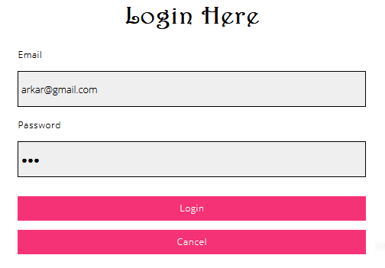

After Testing

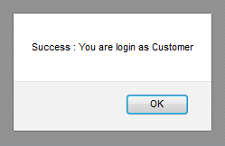

Fig: 1.2

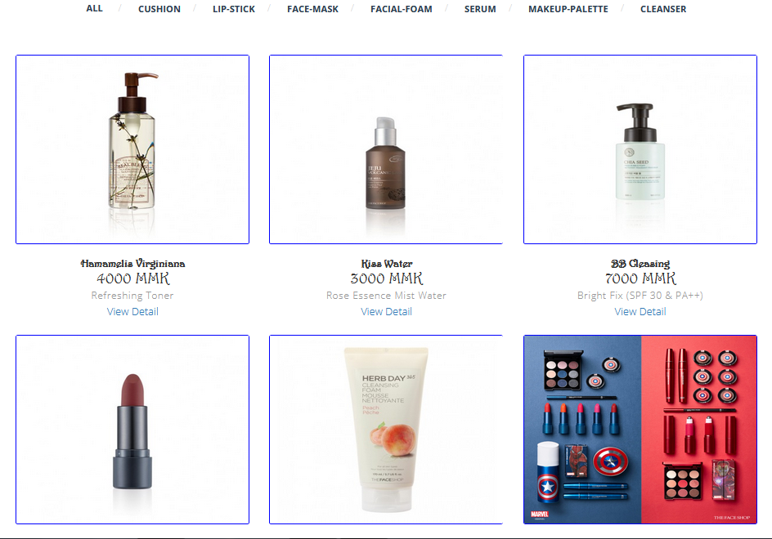

|  |  |  |  |  |  |
| --- | --- | --- | --- | --- | --- |
| Test Case | Description | Test Data | Test Procedure | Expected Result | Actual Results |
| 1.2 | Test the login by customers’ accounts. | Email= mha@gmail.com  Password = 88888888 | Type user email address and the password in text box and click Login button. | Show welcome message box and show product display page. | See Fig.1.4 and Fig 1.5 |

Before Testing

Fig: 1.3

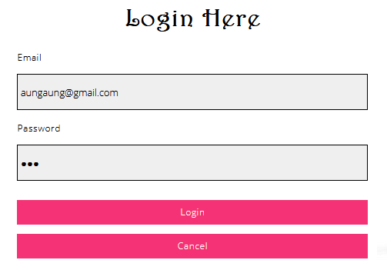

After Testing

Fig: 1.4

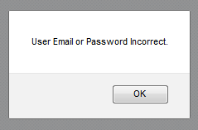

Fig: 1.5

|  |  |  |  |  |  |
| --- | --- | --- | --- | --- | --- |
| Test Case | Description | Test Data | Test Procedure | Expected Result | Actual Results |
| 1.3 | Testing the log in the web page with invalid user email. | Email = [aa@gmail.com](mailto:aa@gmail.com)  Password = 888888888 | Type invalid email and the password in text box and click Login button. | Show alert message box and fill correct user email. | See Fig.1.7 |

Before Testing

Fig : 1.6

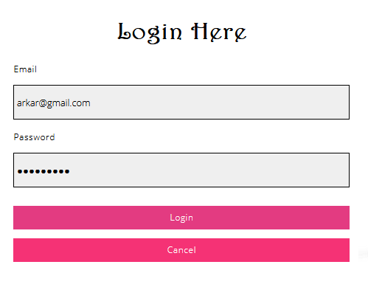

After Testing

Fig: 1.7



|  |  |  |  |  |  |
| --- | --- | --- | --- | --- | --- |
| Test Case | Description | Test Data | Test Procedure | Expected Result | Actual Results |
| 1.4 | Login with correct email address and wrong password. | Email = mha@gmail.com  Password = 5859858587 | Type correct email address and the wrong  password in text box and click Login button. | Show alert message box and fill correct password.. | See Fig.1.9 |

Before Testing

Fig : 1.8

After Testing

Fig: 1.9

|  |  |  |  |  |  |  |
| --- | --- | --- | --- | --- | --- | --- |
| Unit Test 2 | | | Test Case: Check input fields accept only correct email value. | Designed by: Aung Min Myat | | |
| Data Source: Customer Register | | | Objective: To test alert box appears. | Tester: Aung Min Myat | | |
| Test Case | Description | Test Data | Test Procedure | Expected Result | Actual Results |
| 2.2 | Fill information but didn’t type @gmail.com in Email input field. | Customer Name=  NRC Number=  Birthday=  Gender=  Mobile Phone= | Didn’t type @gmail.com in Email input field. | Field become box red. | See Fig.2.1 |

Before Testing

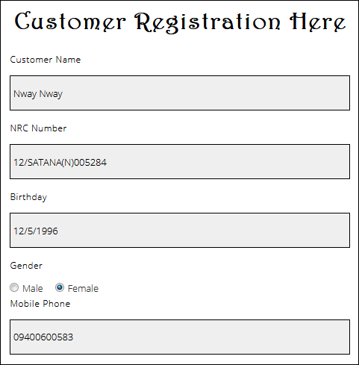

Fig. 2.0

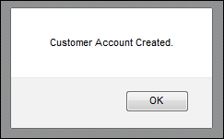

After Testing

Fig 2.1

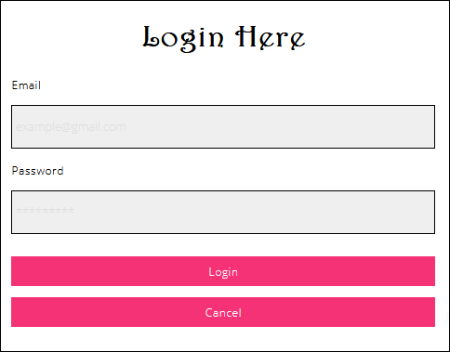

|  |  |  |  |  |  |
| --- | --- | --- | --- | --- | --- |
| Test Case | Description | Test Data | Test Procedure | Expected Result | Actual Results |
| 2.3 | Fill all input fields and only type 7 or less than 8 passwords in password field. | Email=  Create Username=  Create Password=  Retype Password=  Address=  Security Answer= | Type 7 or less than 8 passwords in password field.  . | Show alert message box to fill 8 or more passwords. | See Fig.2.3 |

Before Testing

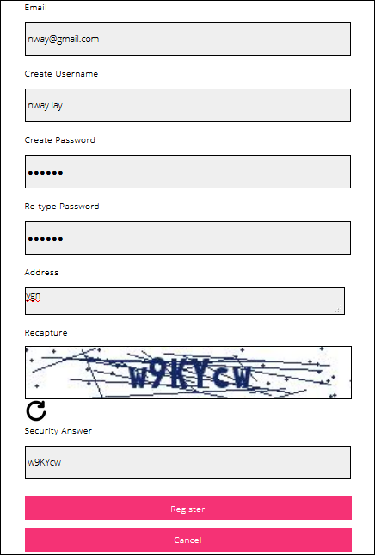

Fig. 2.2

After Testing



Fig 2.3



|  |  |  |  |  |  |
| --- | --- | --- | --- | --- | --- |
| Test Case | Description | Test Data | Test Procedure | Expected Result | Actual Results |
| 2.4 | Checks confirm password is same as the as password that user type above. |  | Type something different with the password that user type above.  . | Show alert message box to type same password that user type above field. | See Fig.2.5 |

Before Testing

Fig. 2.4

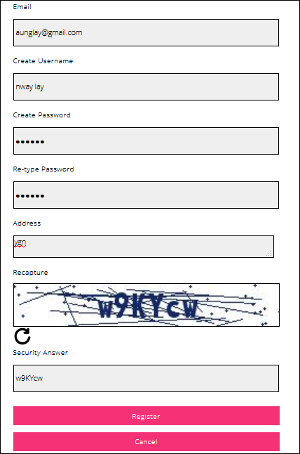

After Testing

Fig 2.5

|  |  |  |  |  |  |
| --- | --- | --- | --- | --- | --- |
| Test Case | Description | Test Data | Test Procedure | Expected Result | Actual Results |
| 2.6 | Check web server that user same email address that is already used to create account.. | Customer Name= MHA  Phone=09999999  Email = mha@gmail.com  Password =12345678  Confim Password= 12345678  Address= Ahlone  Gender= Male | Type same email address that is already used to create account.  . | Show alert message box that email is already used. | See Fig.2.7 |

Before Testing

Fig. 2.6

After Testing

Fig 2.7

|  |  |  |  |  |  |  |
| --- | --- | --- | --- | --- | --- | --- |
| Unit Test 3 | | | Test Case: Test data entry fields cannot be null value. | Designed by: Aung Min Myat | | |
| Data Source: Product Register | | | Objective: To test the entry fields didn’t accept null value. | Tester: Aung Min Myat | | |
| Test Case | Description | Test Data | Test Procedure | Expected Result | Actual Results |
| 3.1 | Check the fields can’t be null. | Product Name=  Category Type=  Quantity=  Price=  Description=  Image= | Type nothing in input fields and click register button.  . | Show alert message box that email is already used. | See Fig.2.9 |

Before Testing

Fig.2.8

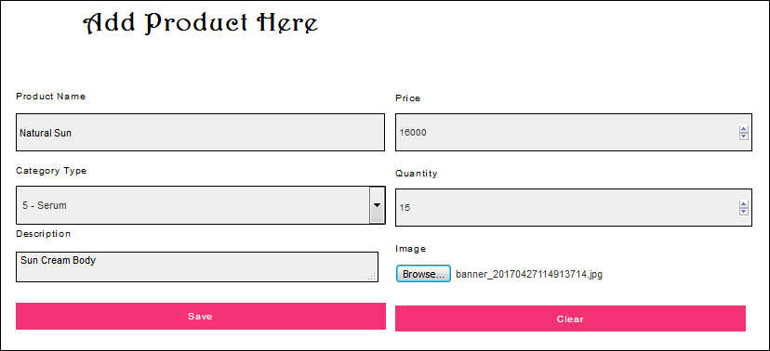

After Testing

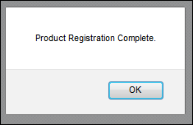

Fig 2.9

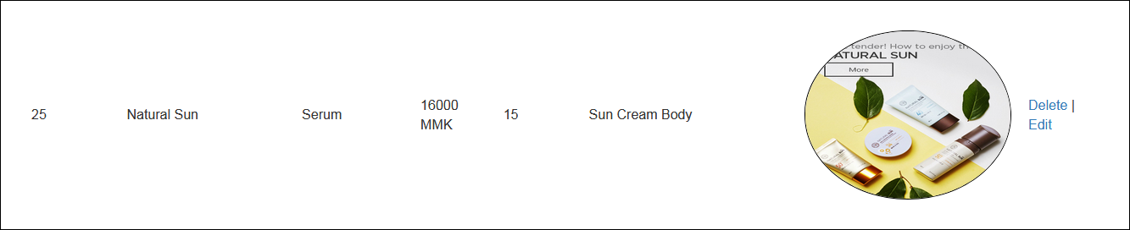

|  |  |  |  |  |  |
| --- | --- | --- | --- | --- | --- |
| Test Case | Description | Test Data | Test Procedure | Expected Result | Actual Results |
| 3.2 | Check that products are edit data. | Product Name=Hotwheels-challenger  Category Name= Cars  Brand Name= Hot Wheels  Price=2700  Quantity=28  Description=Muscle Mania  Image=images/-Charger.jpg | Fill all fields that web page ask to change that price, description and quantity. | Show register product message. | See Fig.3.1 |

Before Testing

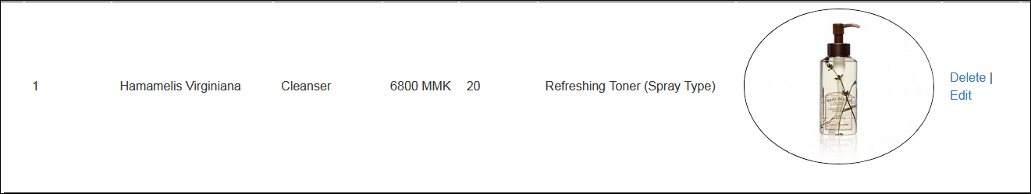

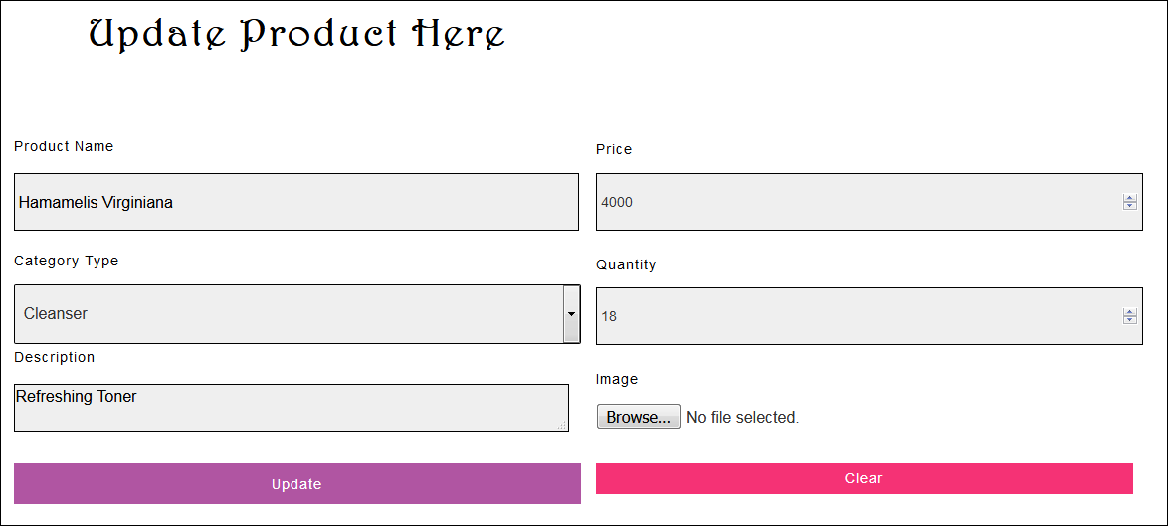

Fig.3.0

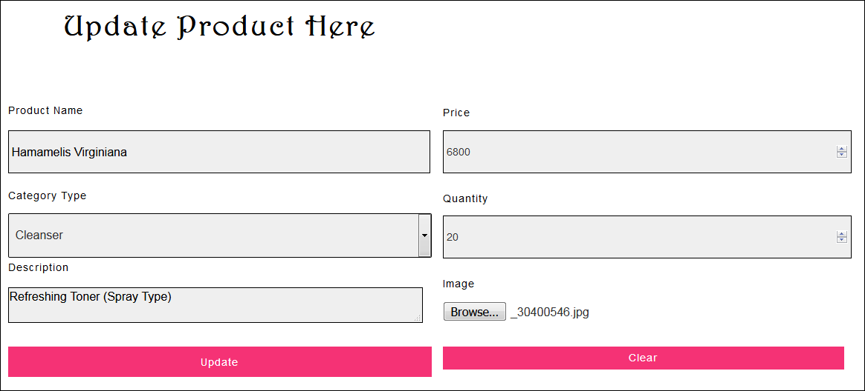

After Testing

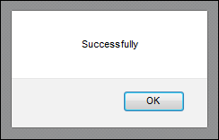

Fig 3.1

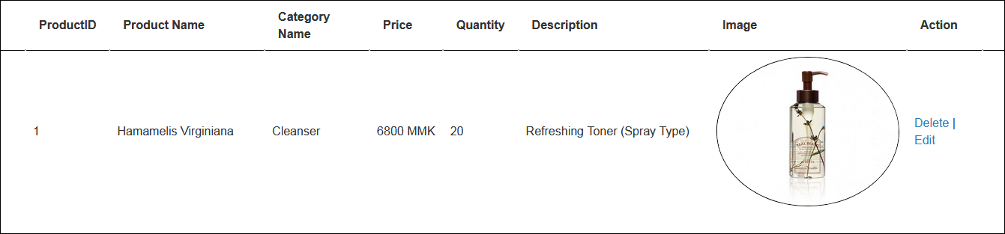

|  |  |  |  |  |  |
| --- | --- | --- | --- | --- | --- |
| Test Case | Description | Test Data | Test Procedure | Expected Result | Actual Results |
| 3.3 | Check input fields didn’t accept null value. | Product Name: Strike Freedom Gundam  Category Name:  Brand Name:  Price:38000  Quantity:22  Description:  Path: | Type nothing and click delete button. | Show alert message to fill input fields. | See Fig.3.3 |

Before Testing

Fig.3.2



After Testing

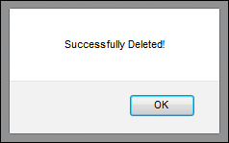

Fig 3.3

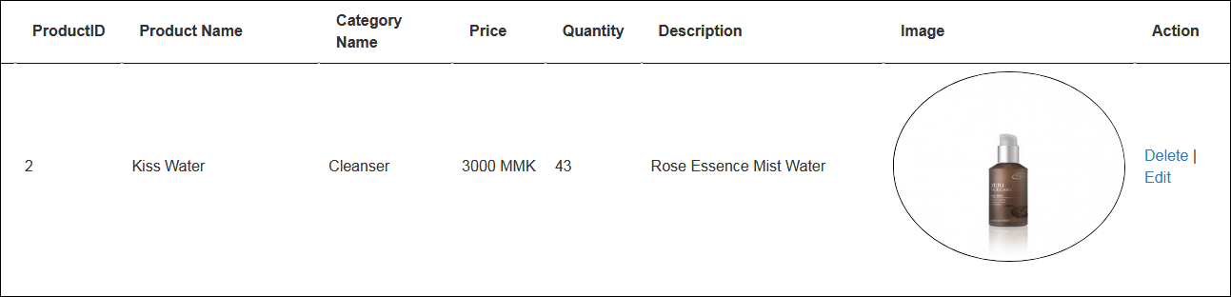

|  |  |  |  |  |  |
| --- | --- | --- | --- | --- | --- |
| Test Case | Description | Test Data | Test Procedure | Expected Result | Actual Results |
| 3.4 | Check updated products are change in database. | Product Name: A  Category Name:  Brand Name:  Price:  Quantity:  Description:  Path: | Alert box appear and show that product is updated. | Product is updated in database. | See Fig.3.5 |

Before Testing

Fig.3.4

After Testing

Fig 3.5

|  |  |  |  |  |  |
| --- | --- | --- | --- | --- | --- |
| Test Case | Description | Test Data | Test Procedure | Expected Result | Actual Results |
| 3.5 | Check deleted products are removed in database. | Click delete button. | Alert box appear and show that product is delete. | Product is deleted in database. | See Fig.3.7 |

Before Testing

Fig.3.6

After Testing

Fig 3.7

|  |  |  |  |  |  |  |
| --- | --- | --- | --- | --- | --- | --- |
| Unit Test 4 | | | Test Case: Test data entry fields cannot be null value. | Designed by: Aung Min Myat | | |
| Data Source: Category Register | | | Objective: To test the entry fields didn’t accept null value. | Tester: Aung Min Myat | | |
| Test Case | Description | Test Data | Test Procedure | Expected Result | Actual Results |
| 4.1 | Check the fields can’t be null. | Category Name= | Type nothing in input fields and click register button.  . | Show alert message box that fill the blanks. | See Fig.3.9 |

Before Testing

Fig. 3.8

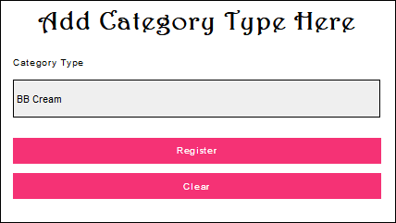

After Testing

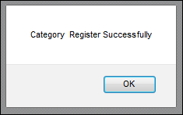

Fig 3.9

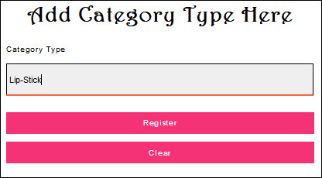

|  |  |  |  |  |  |
| --- | --- | --- | --- | --- | --- |
| Test Case | Description | Test Data | Test Procedure | Expected Result | Actual Results |
| 4.2 | Check that register category are add in database. | Category name= Cars | Fill all fields that web page ask. | Data is stored in database. | See Fig.4.1 |

Before Testing

Fig.4.0

After Testing

Fig. 4.1

|  |  |  |  |  |  |
| --- | --- | --- | --- | --- | --- |
| Test Case | Description | Test Data | Test Procedure | Expected Result | Actual Results |
| 4.3 | Check updated category is change in database. | Category  Name= Car | Alert box appear and show that category is updated. | Category is updated in database. | See Fig.4.3 |

Before Testing

Fig.4.2

After Testing

Fig 4.3

|  |  |  |  |  |  |
| --- | --- | --- | --- | --- | --- |
| Test Case | Description | Test Data | Test Procedure | Expected Result | Actual Results |
| 4.4 | Check deleted category is removed in database. | Click delete button. | Alert box appear and show that product is delete. | Brand is deleted in database. | See Fig.4.5 |

Before Testing

Fig.4.4

After Testing

Fig 4.5

|  |  |  |  |  |  |  |
| --- | --- | --- | --- | --- | --- | --- |
| Unit Test 5 | | | Test Case: Test data entry fields cannot be null value. | Designed by: Aung Min Myat | | |
| Data Source: Brand Register | | | Objective: To test the entry fields didn’t accept null value. | Tester: Aung Min Myat | | |
| Test Case | Description | Test Data | Test Procedure | Expected Result | Actual Results |
| 5.1 | Check the fields can’t be null. | Brand Name= | Type nothing in input fields and click register button.  . | Show alert message box that fill the blanks. | See Fig.4.7 |

Before Testing

Fig.4.6

After Testing

Fig 4.7

|  |  |  |  |  |  |
| --- | --- | --- | --- | --- | --- |
| Test Case | Description | Test Data | Test Procedure | Expected Result | Actual Results |
| 5.2 | Check that register brands are add in database. | Brand name= Hot Wheels | Fill all fields that web page ask. | Show alert message that brand is successfully register. | See Fig.4.9 |

Before Testing

Fig.4.8

After Testing

Fig 4.9

|  |  |  |  |  |  |
| --- | --- | --- | --- | --- | --- |
| Test Case | Description | Test Data | Test Procedure | Expected Result | Actual Results |
| 5.3 | Check input fields didn’t accept null value. | Brand  Name= | Type nothing and click register button. | Show alert message to fill input fields. | See Fig.5.1 |

Before Testing

Fig.5.0

After Testing

Fig 5.1

|  |  |  |  |  |  |
| --- | --- | --- | --- | --- | --- |
| Test Case | Description | Test Data | Test Procedure | Expected Result | Actual Results |
| 5.4 | Check updated brand is change in database. | Category Name= Doll | Alert box appear and show that brand is updated. | Brand is updated in database. | See Fig.5.3 |

Before Testing

Fig.5.2

After Testing

Fig 5.3

|  |  |  |  |  |  |
| --- | --- | --- | --- | --- | --- |
| Test Case | Description | Test Data | Test Procedure | Expected Result | Actual Results |
| 5.5 | Check deleted brand is removed in database. | Click delete button. | Alert box appear and show that brand is delete. | Brand is deleted in database. | See Fig.5.5 |

Before Testing

Fig.5.4

After Testing

Fig 5.5

|  |  |  |  |  |  |  |
| --- | --- | --- | --- | --- | --- | --- |
| Unit Test 6 | | | Test Case: To test the view detail button is hide. | Designed by: Aung Min Myat | | |
| Data Source: Product Display | | | Objective: Hide view detail button when user is not login. | Tester: Aung Min Myat | | |
| Test Case | Description | Test Data | Test Procedure | Expected Result | Actual Results |
| 6.1 | Check view detail didn’t shown up without user login. | Hide view detail button. | View detail button is hide when user is not login. | View detail button is hide. | See Fig.5.7 |

Before Testing

Fig.5.6

After Testing

Fig 5.7

|  |  |  |  |  |  |
| --- | --- | --- | --- | --- | --- |
| Test Case | Description | Test Data | Test Procedure | Expected Result | Actual Results |
| 6.2 | Check view detail button is shown up. | Login and check view detail button is appearing. | View detail button is shown under the products. | View detail button is appearing. | See Fig.5.9 |

Before Testing

Fig.5.8

After Testing

Fig 5.9

|  |  |  |  |  |  |
| --- | --- | --- | --- | --- | --- |
| Test Case | Description | Test Data | Test Procedure | Expected Result | Actual Results |
| 6.3 | Check view button is works. | Click view detail button. | User can click view detail button and get to purchase page. | User can get to purchase page. | See Fig.6.1 |

Before Testing

Fig.6.0

After Testing

Fig 6.1

|  |  |  |  |  |  |
| --- | --- | --- | --- | --- | --- |
| Test Case | Description | Test Data | Test Procedure | Expected Result | Actual Results |
| 6.4 | Check login button is change to logout button. | Login button is changed to logout button. | Login button is change to logout button when user is login. | Login button is change to Logout button in display page. | See Fig.6.3 |

Before Testing

Fig.6.2

After Testing

Fig. 6.3

|  |  |  |  |  |  |  |
| --- | --- | --- | --- | --- | --- | --- |
| Unit Test 7 | | | Test Case: To test the product is decrease when customer bought the product. | Designed by: Aung Min Myat | | |
| Data Source: Product Detail | | | Objective: Product is decrease in quantity. | Tester: Aung Min Myat | | |
| Test Case | Description | Test Data | Test Procedure | Expected Result | Actual Results |
| 7.1 | Check that product quantity is decrease. | Click add to cart button | The product quantity is decrease. | Product quantity is decrease from 2 to 1. | See Fig.6.5 |

Before Testing

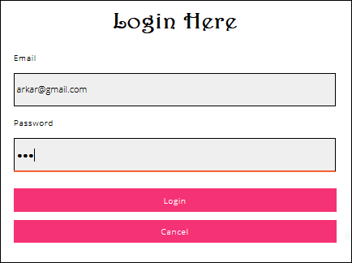

Fig.6.4

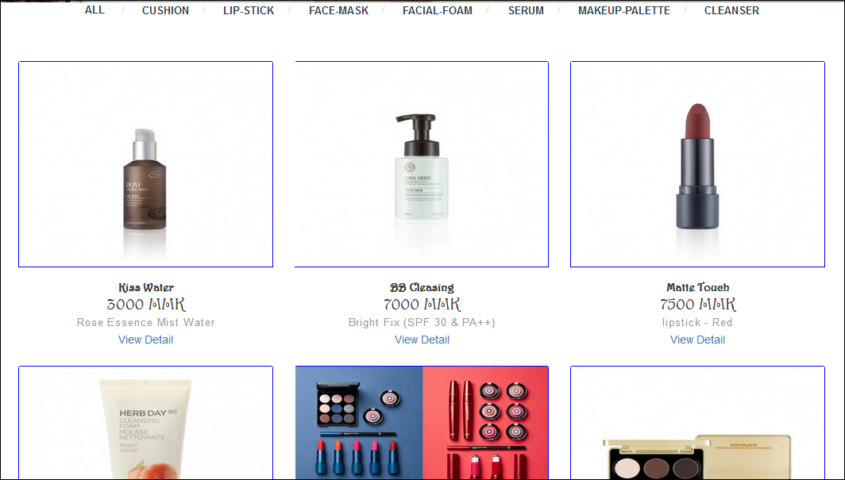

After Testing

Fig 6.5

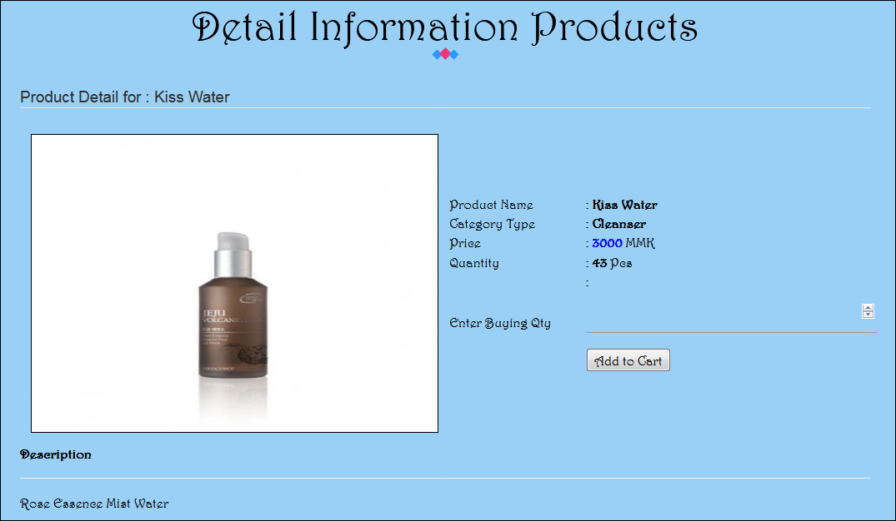

|  |  |  |  |  |  |
| --- | --- | --- | --- | --- | --- |
| Test Case | Description | Test Data | Test Procedure | Expected Result | Actual Results |
| 7.2 | Check that customer can buy products. | Click purchase button. | Customer can buy products in detail page. | The products which customers bought are stored in database. | See Fig.6.7 |

Before Testing

Fig.6.6

After Testing

Fig 6.7

|  |  |  |  |  |  |
| --- | --- | --- | --- | --- | --- |
| Test Case | Description | Test Data | Test Procedure | Expected Result | Actual Results |
| 7.3 | Check the customer can’t buy over quantity which is stored in database. | Fill the product quantity more than stored in quantity. | Customer can’t buy quantity more than stored in database. | Alert box appear and show message that out of stocks. | See Fig.6.9 |

Before Testing

Fig. 6.8

After Testing

Fig 6.9

|  |  |  |  |  |  |  |
| --- | --- | --- | --- | --- | --- | --- |
| Unit Test 8 | | | Test Case: To test that admin can confirm order. | Designed by: Aung Min Myat | | |
| Data Source: Order Confirm | | | Objective: Change pending status to confirm status. | Tester: Aung Min Myat | | |
| Test Case | Description | Test Data | Test Procedure | Expected Result | Actual Results |
| 8.1 | Check that admin can confirm the customer’s order. | Click the order confirm button. | Admin click the order confirm button of the customer’s order. | When admin click order confirm button, the product will appear in delivery schedule page. | See Fig.7.1 |

Before Testing

Fig. 7.0

After Testing

Fig. 7.1

|  |  |  |  |  |  |
| --- | --- | --- | --- | --- | --- |
| Test Case | Description | Test Data | Test Procedure | Expected Result | Actual Results |
| 8.2 | Check that show all button is works. | Click the show all button. | Admin click the show all button and all the orders are appear. | When admin click show all button, all the orders are shown up. | See Fig.7.3 |

Before Testing

Fig. 7.2

After Testing

Fig. 7.3

|  |  |  |  |  |  |
| --- | --- | --- | --- | --- | --- |
| Test Case | Description | Test Data | Test Procedure | Expected Result | Actual Results |
| 8.3 | Check that admin can search the orders with date. | Click the search button. | Admin click the search button. | When admin click search button, the customer’s orders will appear. | See Fig.7.5 |

Before Testing

Fig. 7.4

After Testing

Fig. 7.5

|  |  |  |  |  |  |
| --- | --- | --- | --- | --- | --- |
| Test Case | Description | Test Data | Test Procedure | Expected Result | Actual Results |
| 8.4 | Check that admin can search the orders with customer’s name. | Click the search button. | Admin click the search button. | When admin click search button, the customer’s orders will appear. | See Fig.7.7 |

Before Testing

Fig. 7.6

After Testing

Fig 7.7

|  |  |  |  |  |  |
| --- | --- | --- | --- | --- | --- |
| Test Case | Description | Test Data | Test Procedure | Expected Result | Actual Results |
| 8.5 | Check that admin can search the orders with product name. | Click the search button. | Admin click the search button. | When admin click search button, the customer’s orders will appear. | See Fig.7.9 |

Before Testing

Fig. 7.8

After Testing

Fig. 7.9

|  |  |  |  |  |  |  |
| --- | --- | --- | --- | --- | --- | --- |
| Unit Test 9 | | | Test Case: To test add button is work. | Designed by: Aung Min Myat | | |
| Data Source: Purchase | | | Objective: To add product which is purchase | Tester: Aung Min Myat | | |
| Test Case | Description | Test Data | Test Procedure | Expected Result | Actual Results |
| 9.1 | Check that add button is work. | Click the add button. | Admin choice the product and click the add button. | When admin click add button, the product will appear in web page. | See Fig.8.1 |

Before Testing

Fig. 8.0

After Testing

Fig. 8.1

|  |  |  |  |  |  |
| --- | --- | --- | --- | --- | --- |
| Test Case | Description | Test Data | Test Procedure | Expected Result | Actual Results |
| 9.2 | Check that purchase button is work. | Click the purchase button. | Admin choice the product and click the purchase button. | When admin click add button, the product will store in database. | See Fig.8.3 |

Before Testing

Fig. 8.2

After Testing

Fig. 8.3

|  |  |  |  |  |  |
| --- | --- | --- | --- | --- | --- |
| Test Case | Description | Test Data | Test Procedure | Expected Result | Actual Results |
| 9.3 | Check that remove button is work. | Click the remove button. | Admin choice the product and click the remove button. | When admin click remove button, the product will remove in web page. | See Fig.8.5 |

Before Testing

Fig.8.4

After Testing

Fig 8.5

|  |  |  |  |  |  |  |
| --- | --- | --- | --- | --- | --- | --- |
| Unit Test 10 | | | Test Case: To test that admin can search the orders with date. | Designed by: Aung Min Myat | | |
| Data Source: Delivery | | | Objective: To appear the orders which are searched by date | Tester: Aung Min Myat | | |
| Test Case | Description | Test Data | Test Procedure | Expected Result | Actual Results |
| 10.1 | Check that admin can search the orders with date. | Click the search button. | Admin click the search button. | When admin click search button, the customer’s orders will appear. | See Fig.8.7 |

Before Testing

Fig. 8.6

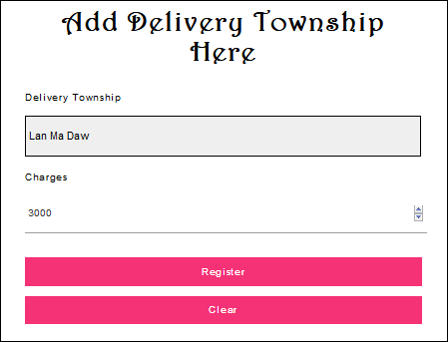

After Testing

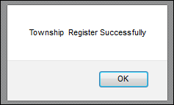

Fig. 8.7

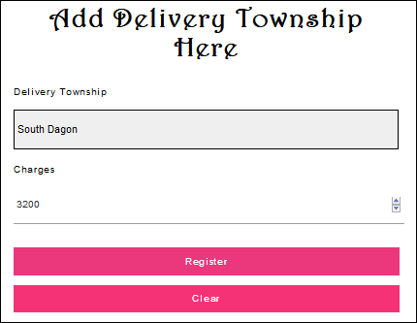

|  |  |  |  |  |  |
| --- | --- | --- | --- | --- | --- |
| Test Case | Description | Test Data | Test Procedure | Expected Result | Actual Results |
| 10.2 | Check that admin can see the delivered products with date. | Click the search button. | Admin click the search button. | When admin click search button, the customer’s orders will appear. | See Fig.8.9 |

Before Testing

Fig: 8.8

After Testing

Fig: 8.9

|  |  |  |  |  |  |  |
| --- | --- | --- | --- | --- | --- | --- |
| Unit Test 2 | | | Test Case: Check input fields accept only correct email value. | Designed by: Aung Min Myat | | |
| Data Source: Staff Register | | | Objective: To test alert box appears. | Tester: Aung Min Myat | | |
| Test Case | Description | Test Data | Test Procedure | Expected Result | Actual Results |
| 2.2 | Fill information but didn’t type @gmail.com in Email input field. | Customer Name=  NRC Number=  Birthday=  Gender=  Mobile Phone= | Didn’t type @gmail.com in Email input field. | Field become box red. | See Fig.2.1 |

Before Testing

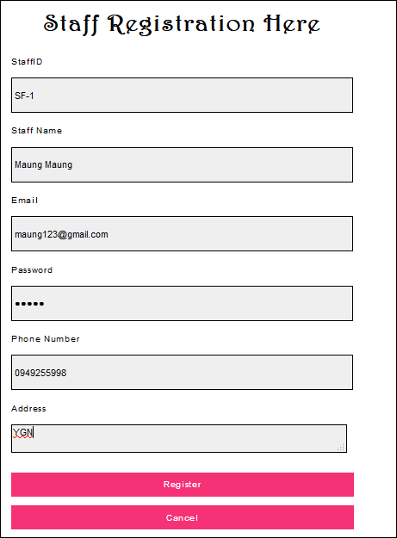

Fig. 9.0

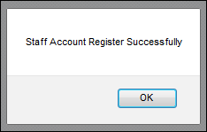

After Testing

Fig. 9.1

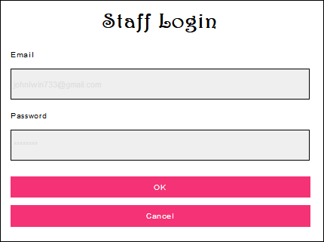

|  |  |  |  |  |  |  |
| --- | --- | --- | --- | --- | --- | --- |
| Unit Test 1 | | | Test Case: To test the web page didn’t accept the null value. | Designed by: Aung Min Myat | | |
| Data Source: Staff Login | | | Objective: To test the alert box appears. | Tester: Aung Min Myat | | |
| Test Case | Description | Test Data | Test Procedure | Expected Result | Actual Results |
| 1.1 | Testing the web page ask the staff to fill all information when the box is empty. | Email = [arkar@gmail.com](mailto:arkar@gmail.com)  Password = 123 | Type login button without filling information. | Show alert box to fill information in blank boxes. | See Fig.1.2 |

Before Testing

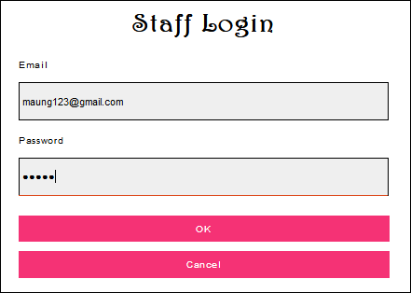

Fig. 9.0

After Testing

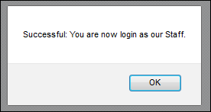

Fig. 9.1

|  |  |  |  |  |  |  |
| --- | --- | --- | --- | --- | --- | --- |
| Unit Test 1 | | | Test Case: To test the web page didn’t accept the null value. | Designed by: Aung Min Myat | | |
| Data Source: Didn’t accept the null value. | | | Objective: To test the alert box appears. | Tester: Aung Min Myat | | |
| Test Case | Description | Test Data | Test Procedure | Expected Result | Actual Results |
| 1.1 | Testing the web page ask the staff to fill all information when the box is empty. | Email = [arkar@gmail.com](mailto:arkar@gmail.com)  Password = 123 | Type login button without filling information. | Show alert box to fill information in blank boxes. | See Fig.1.2 |

|  |  |  |  |  |  |  |
| --- | --- | --- | --- | --- | --- | --- |
| Unit Test 1 | | | Test Case: To test the web page didn’t accept the null value. | Designed by: Aung Min Myat | | |
| Data Source: Didn’t accept the null value. | | | Objective: To test the alert box appears. | Tester: Aung Min Myat | | |
| Test Case | Description | Test Data | Test Procedure | Expected Result | Actual Results |
| 1.1 | Testing the web page ask the staff to fill all information when the box is empty. | Email = [arkar@gmail.com](mailto:arkar@gmail.com)  Password = 123 | Type login button without filling information. | Show alert box to fill information in blank boxes. | See Fig.1.2 |

|  |  |  |  |  |  |  |
| --- | --- | --- | --- | --- | --- | --- |
| Unit Test 1 | | | Test Case: To test the web page didn’t accept the null value. | Designed by: Aung Min Myat | | |
| Data Source: Didn’t accept the null value. | | | Objective: To test the alert box appears. | Tester: Aung Min Myat | | |
| Test Case | Description | Test Data | Test Procedure | Expected Result | Actual Results |
| 1.1 | Testing the web page ask the staff to fill all information when the box is empty. | Email = [arkar@gmail.com](mailto:arkar@gmail.com)  Password = 123 | Type login button without filling information. | Show alert box to fill information in blank boxes. | See Fig.1.2 |

|  |  |  |  |  |  |  |
| --- | --- | --- | --- | --- | --- | --- |
| Unit Test 1 | | | Test Case: To test the web page didn’t accept the null value. | Designed by: Aung Min Myat | | |
| Data Source: Didn’t accept the null value. | | | Objective: To test the alert box appears. | Tester: Aung Min Myat | | |
| Test Case | Description | Test Data | Test Procedure | Expected Result | Actual Results |
| 1.1 | Testing the web page ask the staff to fill all information when the box is empty. | Email = [arkar@gmail.com](mailto:arkar@gmail.com)  Password = 123 | Type login button without filling information. | Show alert box to fill information in blank boxes. | See Fig.1.2 |

## 

## User Guide

## System Code

**Login**

|  |  |
| --- | --- |
| **Function** | **Description** |
| session_start() : | This function is use to the pull out of the all of data from the other form |
| require_once() | This function is use to pull out of the other page |
| mysql_query() | This function is use to run the select statement |
| mysql_fetch_array() | This function is used to pull out the row of data |
| mysql_num_rows() | This function is use to counting the number of rows |
| insert() | This function is use to the insert data |

**Register Customer**

|  |  |
| --- | --- |
| **Function** | **Description** |
| session_start() : | This function is use to the pull out of the all of data from the other form |
| require_once() | This function is use to pull out of the other page |
| mysql_query() | This function is use to run the select statement |
| mysql_fetch_array() | This function is used to pull out the row of data |
| mysql_num_rows() | This function is use to counting the number of rows |
| insert() | This function is use to the insert data |

**Register Product**

|  |  |
| --- | --- |
| **Function** | **Description** |
| session_start() : | This function is use to the pull out of the all of data from the other form |
| require_once() | This function is use to pull out of the other page |
| mysql_query() | This function is use to run the select statement |
| mysql_fetch_array() | This function is used to pull out the row of data |
| mysql_num_rows() | This function is use to counting the number of rows |
| insert() | This function is use to the insert data |
| update() | This function is use to the update the insert data |

**Register Category**

|  |  |
| --- | --- |
| **Function** | **Description** |
| session_start() | This function is use to the pull out of the all of data from the other form |
| require_once() | This function is use to pull out of the other page |
| mysql_query() | This function is use to run the select statement |
| mysql_fetch_array() | This function is used to pull out the row of data |
| mysql_num_rows() | This function is use to counting the number of rows |
| insert() | This function is use to the insert data |
| update() | This function is use to the update the insert data |
| $_POST() | This function is use to the pulling out of the form of method post data |
| mysql_error | This function is use to show of error form the system |

**Register Supplier**

|  |  |
| --- | --- |
| **Function** | **Description** |
| session_start() : | This function is use to the pull out of the all of data from the other form |
| require_once() | This function is use to pull out of the other page |
| mysql_query() | This function is use to run the select statement |
| mysql_fetch_array() | This function is used to pull out the row of data |
| mysql_num_rows() | This function is use to counting the number of rows |
| insert() | This function is use to the insert data |
| update() | This function is use to the update the insert data |
| $_POST() | This function is use to the pulling out of the form of method post data |
| mysql_error | This function is use to show of error form the system |

**Register Staff**

|  |  |
| --- | --- |
| **Function** | **Description** |
| session_start() : | This function is use to the pull out of the all of data from the other form |
| require_once() | This function is use to pull out of the other page |
| mysql_query() | This function is use to run the select statement |
| mysql_fetch_array() | This function is used to pull out the row of data |
| mysql_num_rows() | This function is use to counting the number of rows |
| insert() | This function is use to the insert data |
| update() | This function is use to the update the insert data |
| $_POST() | This function is use to the pulling out of the form of method post data |
| mysql_error | This function is use to show of error form the system |

**Product-Display**

|  |  |
| --- | --- |
| **Function** | **Description** |
| session_start() | This function is use to the pull out of the all of data from the other form |
| require_once() | This function is use to pull out of the other page |
| mysql_query() | This function is use to run the select statement |
| mysql_fetch_array() | This function is used to pull out the row of data |
| mysql_num_rows() | This function is use to counting the number of rows |
| mysql_error | This function is use to show of error form the system |
| insert() | This function is use to the insert data |
| update() | This function is use to the update the insert data |
| $_GET() | This function is use to pull out the form of method get data |
| $_REQUEST() | This function is use to the pull out of the input type data |
| $_SESSION() | This function is use to pull out of data from the other form |

**Product Detail**

|  |  |
| --- | --- |
| **Function** | **Description** |
| session_start() | This function is use to the pull out of the all of data from the other form |
| require_once() | This function is use to pull out of the other page |
| mysql_query() | This function is use to run the select statement |
| mysql_fetch_array() | This function is used to pull out the row of data |
| mysql_num_rows() | This function is use to counting the number of rows |
| mysql_error | This function is use to show of error form the system |
| insert() | This function is use to the insert data |
| update() | This function is use to the update the insert data |
| $_GET() | This function is use to pull out the form of method get data |
| $_REQUEST() | This function is use to the pull out of the input type data |
| $_SESSION() | This function is use to pull out of data from the other form |

**Shopping Cart**

|  |  |
| --- | --- |
| **Function** | **Description** |
| session_start() | This function is use to the pull out of the all of data from the other form |
| require_once() | This function is use to pull out of the other page |
| mysql_query() | This function is use to run the select statement |
| mysql_fetch_array() | This function is used to pull out the row of data |
| mysql_num_rows() | This function is use to counting the number of rows |
| mysql_error | This function is use to show of error form the system |
| insert() | This function is use to the insert data |
| update() | This function is use to the update the insert data |
| $_GET() | This function is use to pull out the form of method get data |
| $_REQUEST() | This function is use to the pull out of the input type data |
| $_SESSION() | This function is use to pull out of data from the other form |
| Include() | This function is use to pull out of the other page |
| $_POST() | This function is use to the pulling out of the form of method post data |

**Logout**

|  |  |
| --- | --- |
| **Function** | **Description** |
| session_start() | This function is use to the pull out of the all of data from the other form |
| session_destroy() | This function is use to stop all the data from the other form |

**Purchase**

|  |  |
| --- | --- |
| **Function** | **Description** |
| session_start() | This function is use to the pull out of the all of data from the other form |
| require_once() | This function is use to pull out of the other page |
| mysql_query() | This function is use to run the select statement |
| mysql_fetch_array() | This function is used to pull out the row of data |
| mysql_num_rows() | This function is use to counting the number of rows |
| mysql_error | This function is use to show of error form the system |
| insert() | This function is use to the insert data |
| update() | This function is use to the update the insert data |
| $_GET() | This function is use to pull out the form of method get data |
| $_REQUEST() | This function is use to the pull out of the input type data |
| $_SESSION() | This function is use to pull out of data from the other form |
| Include() | This function is use to pull out of the other page |
| $_POST() | This function is use to the pulling out of the form of method post data |

**Delivery**

|  |  |
| --- | --- |
| **Function** | **Description** |
| session_start() | This function is use to the pull out of the all of data from the other form |
| require_once() | This function is use to pull out of the other page |
| mysql_query() | This function is use to run the select statement |
| mysql_fetch_array() | This function is used to pull out the row of data |
| mysql_num_rows() | This function is use to counting the number of rows |
| mysql_error | This function is use to show of error form the system |
| insert() | This function is use to the insert data |
| update() | This function is use to the update the insert data |
| $_GET() | This function is use to pull out the form of method get data |
| $_REQUEST() | This function is use to the pull out of the input type data |
| $_SESSION() | This function is use to pull out of data from the other form |
| Include() | This function is use to pull out of the other page |
| $_POST() | This function is use to the pulling out of the form of method post data |

**Order**

|  |  |
| --- | --- |
| **Function** | **Description** |
| session_start() | This function is use to the pull out of the all of data from the other form |
| require_once() | This function is use to pull out of the other page |
| mysql_query() | This function is use to run the select statement |
| mysql_fetch_array() | This function is used to pull out the row of data |
| mysql_num_rows() | This function is use to counting the number of rows |
| mysql_error | This function is use to show of error form the system |
| insert() | This function is use to the insert data |
| $_GET() | This function is use to pull out the form of method get data |
| $_REQUEST() | This function is use to the pull out of the input type data |
| $_SESSION() | This function is use to pull out of data from the other form |
| Include() | This function is use to pull out of the other page |
| $_POST() | This function is use to the pulling out of the form of method post data |

|  |  |
| --- | --- |
| Functions | Description |
| AutoID | This service will be used to automatically increment the ID number in the desired format number. However, it is important to change complementary tables, properties, prefixes, and datasets. This system makes the system standard, even cooler and more standard. |
| Add | This function can be used to add the size of the item, it is more formal and needs to reduce the wrongness of these features. This functionality can be used in the collection process and other appropriate forms. |
| Remove | This feature is actually used to eliminate the items in the shopping cart, if the customer changes his mind to order. Not only does the element be deleted, it can also be used effectively for other similar operations without the important data being deleted by mistake. |
| Clear | If a client or employee wants to permanently see editorial documents, he himself can click the visible link in the form. So to enable this connection, this clear function () will be required to help maintain the system in the database to reduce unchanged registration. |
| CalculateTotalAmount | It's important to know the total amount of the payment basket shopping. The system is standard and the system is sensitive. With this function, the calculation of the number will be correct, without exception. |
| CalculateTotalQuantity | This function also is used to calculate total quantity when a customer collect items in shopping cart. Just like the above one , this function is also important to be able to know how many item a customer order. |